How to do the Building Foundations Activity


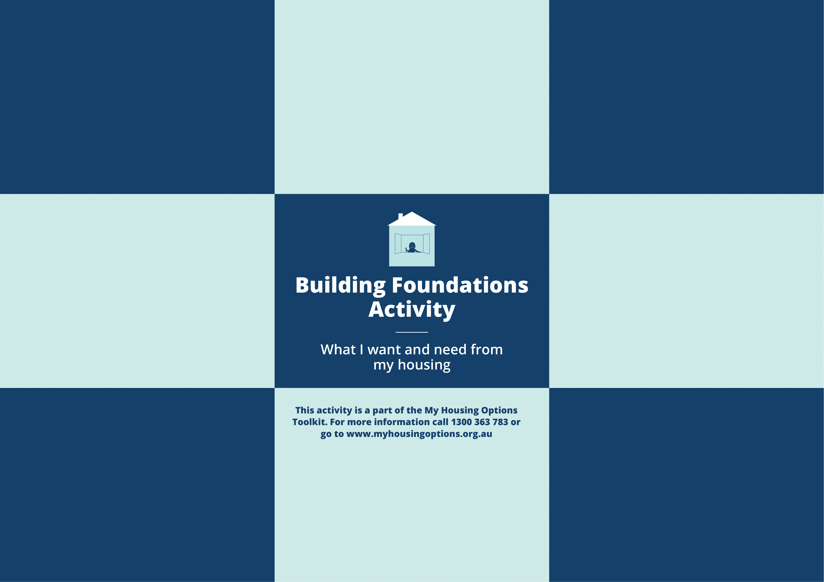
How to do the “Building Foundations” activity

 | Why do the activity?
 | It uses pictures to help you think about what you need and want from your housing.
 | There are lots of things to think about.
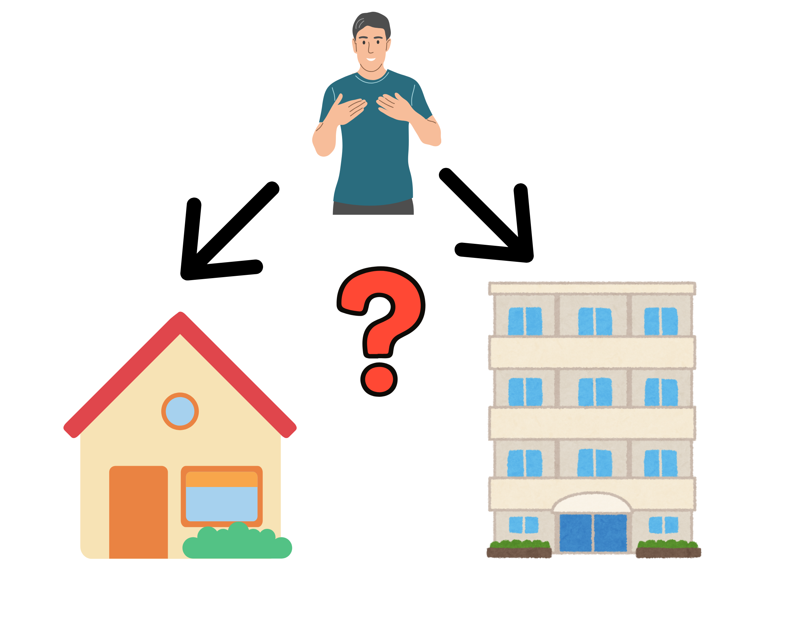 | It helps you look at what choices you have.
 | .  You can take a picture when you are finished.
 | What you need
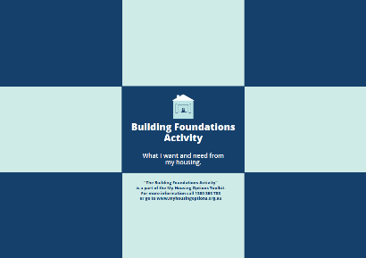  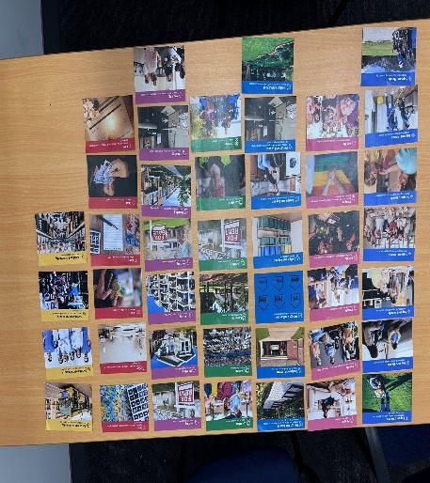 | Building Foundations Board  - This is the big board with the blue rectangles.  Building Foundation cards  - These are smaller rectangle cards with pictures on them.  - There are 41 cards.
 | How to set it up
 | There are different areas to think about when you are making choices about your housing.
 | The activity has 7 different areas to think about.
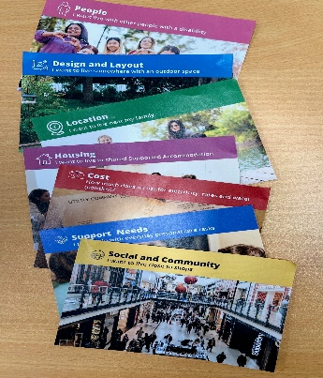 | The cards are 7 different colours.
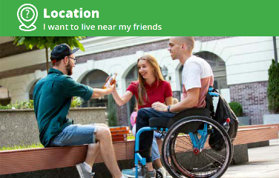  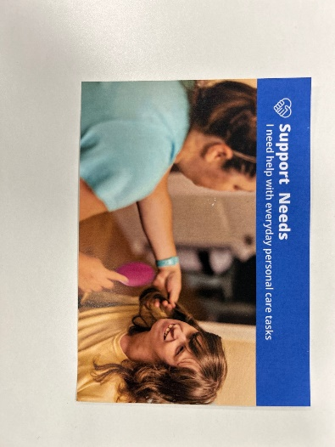   | The different colours show different areas to think about for your needs, likes and choices.  - Like Green is about where you want to live.  - Dark Blue is about support you need.  - Red is about how much things cost.  The cards have different pictures on them.  Some cards ask questions.  Like “How much money will I need for rent or mortgage?” or “How much can I afford to spend?”  You do not need to know the answers to these questions right now.  You might need more time or some more information to find out the answers.  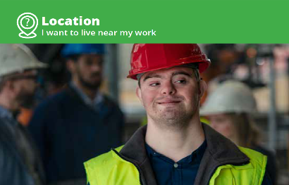  Some cards make statements.  Like “I want to live near where I work” or “I want to live in the country”.
 | How to do the activity?
 | Put all the coloured picture cards on a floor or table.
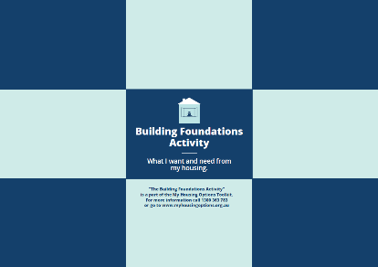 | Put the big board on the ground or table.
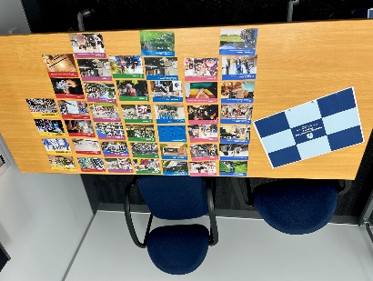 | Have a look at all the coloured cards.
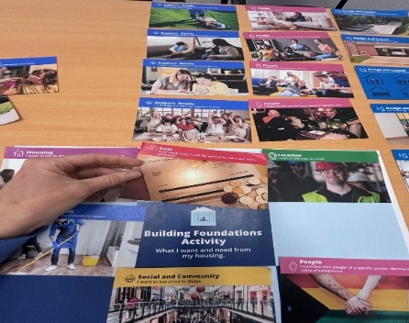 | Choose cards that show the things you want or need.
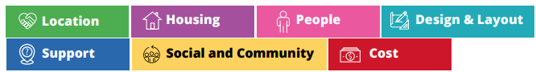  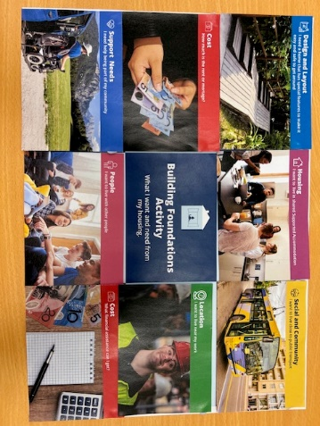 | Put the cards you chose on the big board.
 | You should try to have 1 from each different colour on the big board.
 | You can take a photo when your board is filled.
 | You can take the photo to your support person. This may be your family, an advocate, your NDIS supports co-ordinator.  To understand more about social housing  Call the Queensland Government.  13 74 68  Ask  Where is a Housing Service Centre near me?
 | It can help you to be clear about what you  need and want.
 | Who can help me?
 | You can look through the My Housing Options Workbook.  Or  Call QDN 1300 363 783

