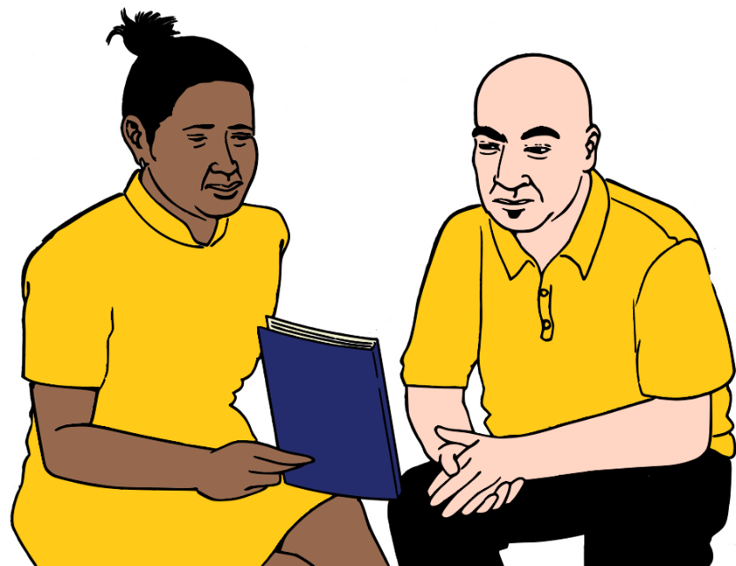
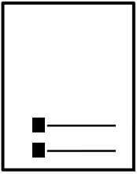


How to plan for where you live.
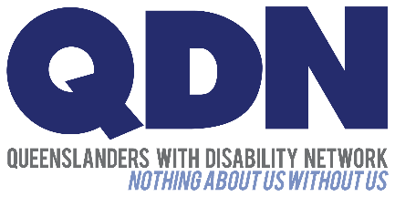

We call it the My Housing Options Workbook.

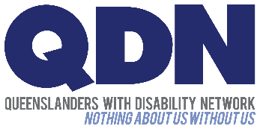
We are Queenslanders with Disability Network. We say QDN. We wrote this.
It is part of the My Housing Options Toolkit.
We call it the Toolkit.

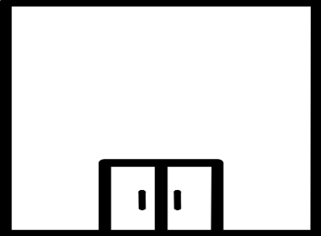

We wrote this with the Queensland Department of Housing and Public Works.
They are part of the Queensland Government.


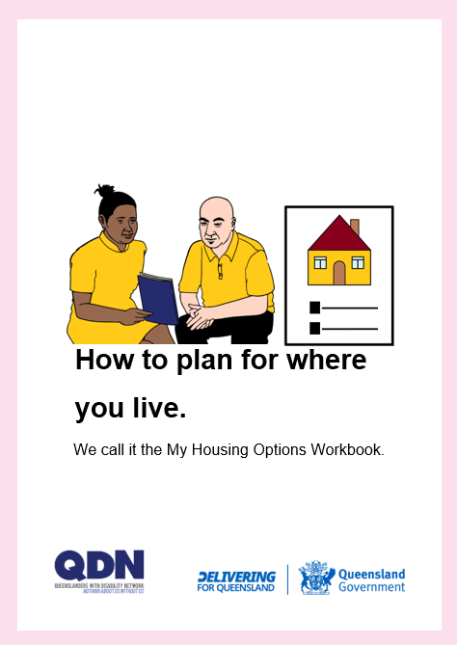
About these books

You want to plan where you will live.
You need to know about your choices.

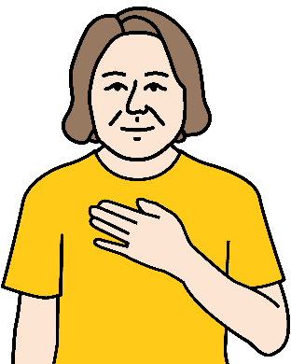

These books are for you.


A person may help you.
Like to do the work sheets.

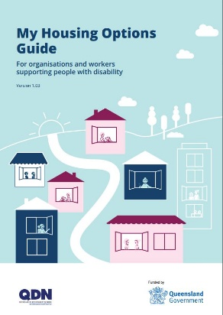
We wrote a different book for them.
We call it the My Housing Options Guide.

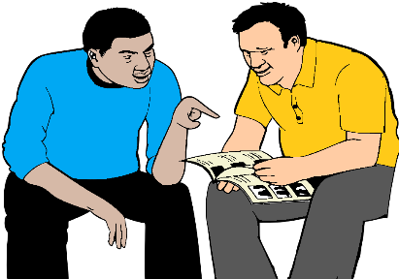
They can help you
- think about your choices for where to live
- plan your own choices.


There are some things to read.

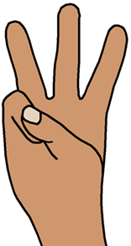
There are 3 steps to do.
We call each step a Building Block.

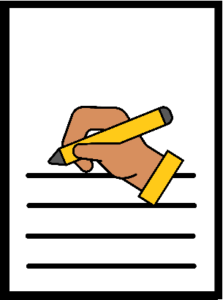

You write your ideas in work sheets.

Then

You put your ideas in a plan.


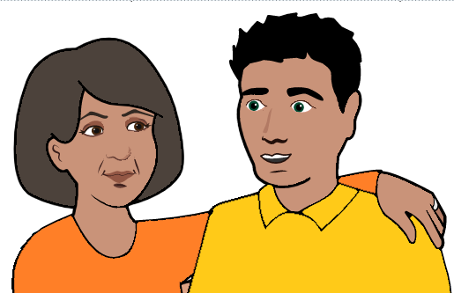
Building Block 1.
You think about where you live now.
Like you live with your mum.

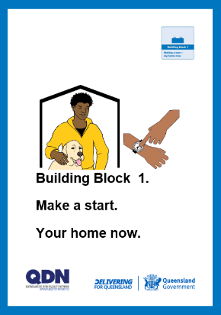
Look for the blue book.
You can do this work sheet.



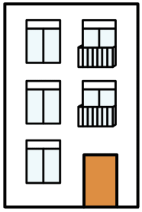
Building Block 2. You think about
- where you want to live
- what your home needs
- what staff help you need. Like help to cook.

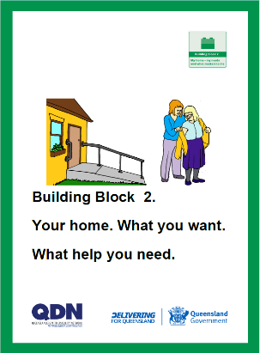
Look for the green book.
You can do these work sheets.


Building Block 3. You think about
- the money you have
- the money you need. It is for your home.

And


You think about what home you will need.
It is in a few years. It helps you plan.

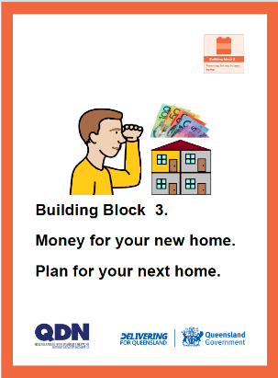
Look for the orange book.
You can do these work sheets

Then

Next step. Your plan.
You write your plan.
The 3 Building Blocks help you.

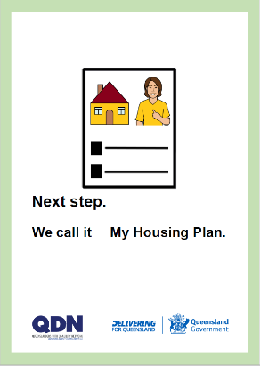

Look for the light green book.

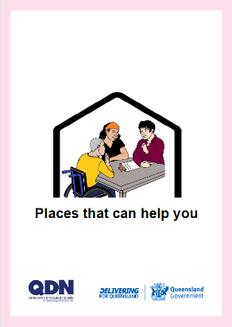
There is a book of help you can get.
Read Places that can help you.

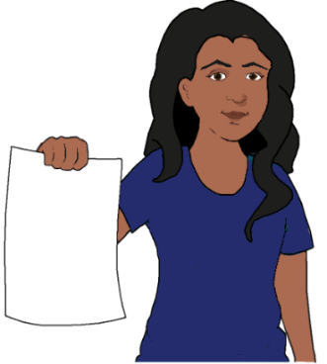
More things in the Toolkit


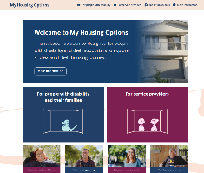
We made a website. The Toolkit is there.
Go to www.MyHousingOptions.org.au.

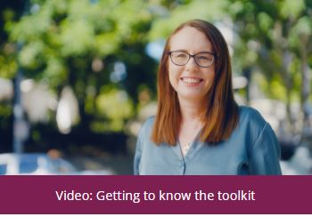
It has videos. People with disability talk about
- what sort of home they have
- how they found their home
- how they keep their home
- how they used the Toolkit.

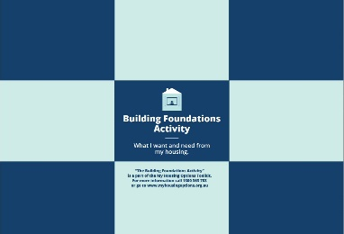
There is a game you can play. It helps you plan
- what you need
- what you like. It is for your home.

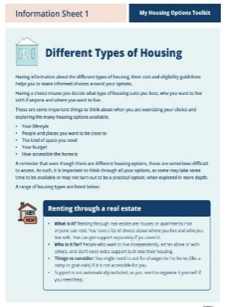
There are 3 information sheets. They are
- Different types of housing
- Financial and other supports
- Your tenancy rights in Queensland.



You may want help to use the Toolkit.

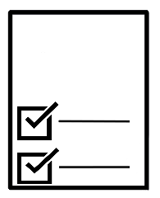

Your rights



You have rights. They are about your home.

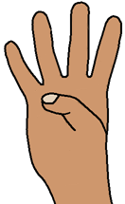
There are 4 big ideas.
We call them the Housing Principles.
QDN wrote them. Other groups helped us.
The Queensland Government uses them.

- You have rights
We all have the same rights. Your rights are
- things you can choose. Like where to live
- things you can do. Like move out of home.

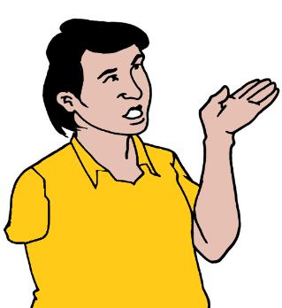
You have the right to say what you think.
It is about where you live. You can talk about
- what is good
- what needs to be better
- what needs to be different.

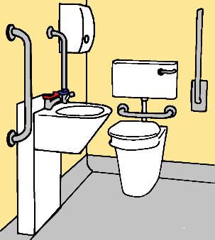
You have the right to ask for what you need.
Like hand rails in the bath room.

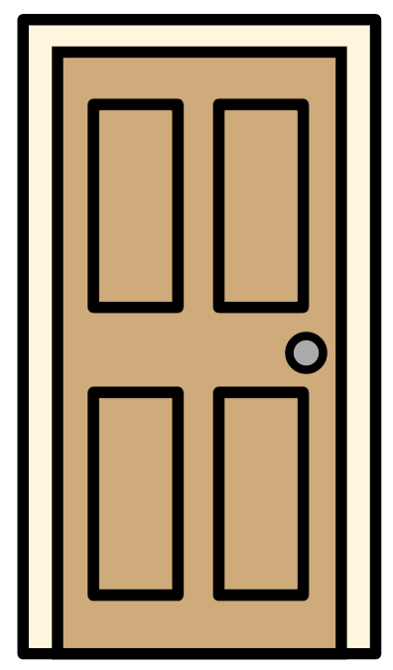
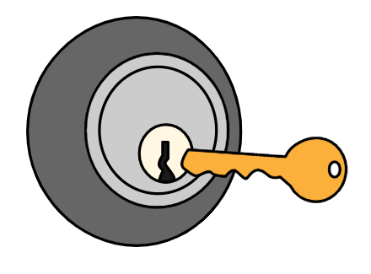
You have the right to a safe home.
Like you can lock your door.


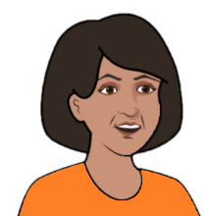
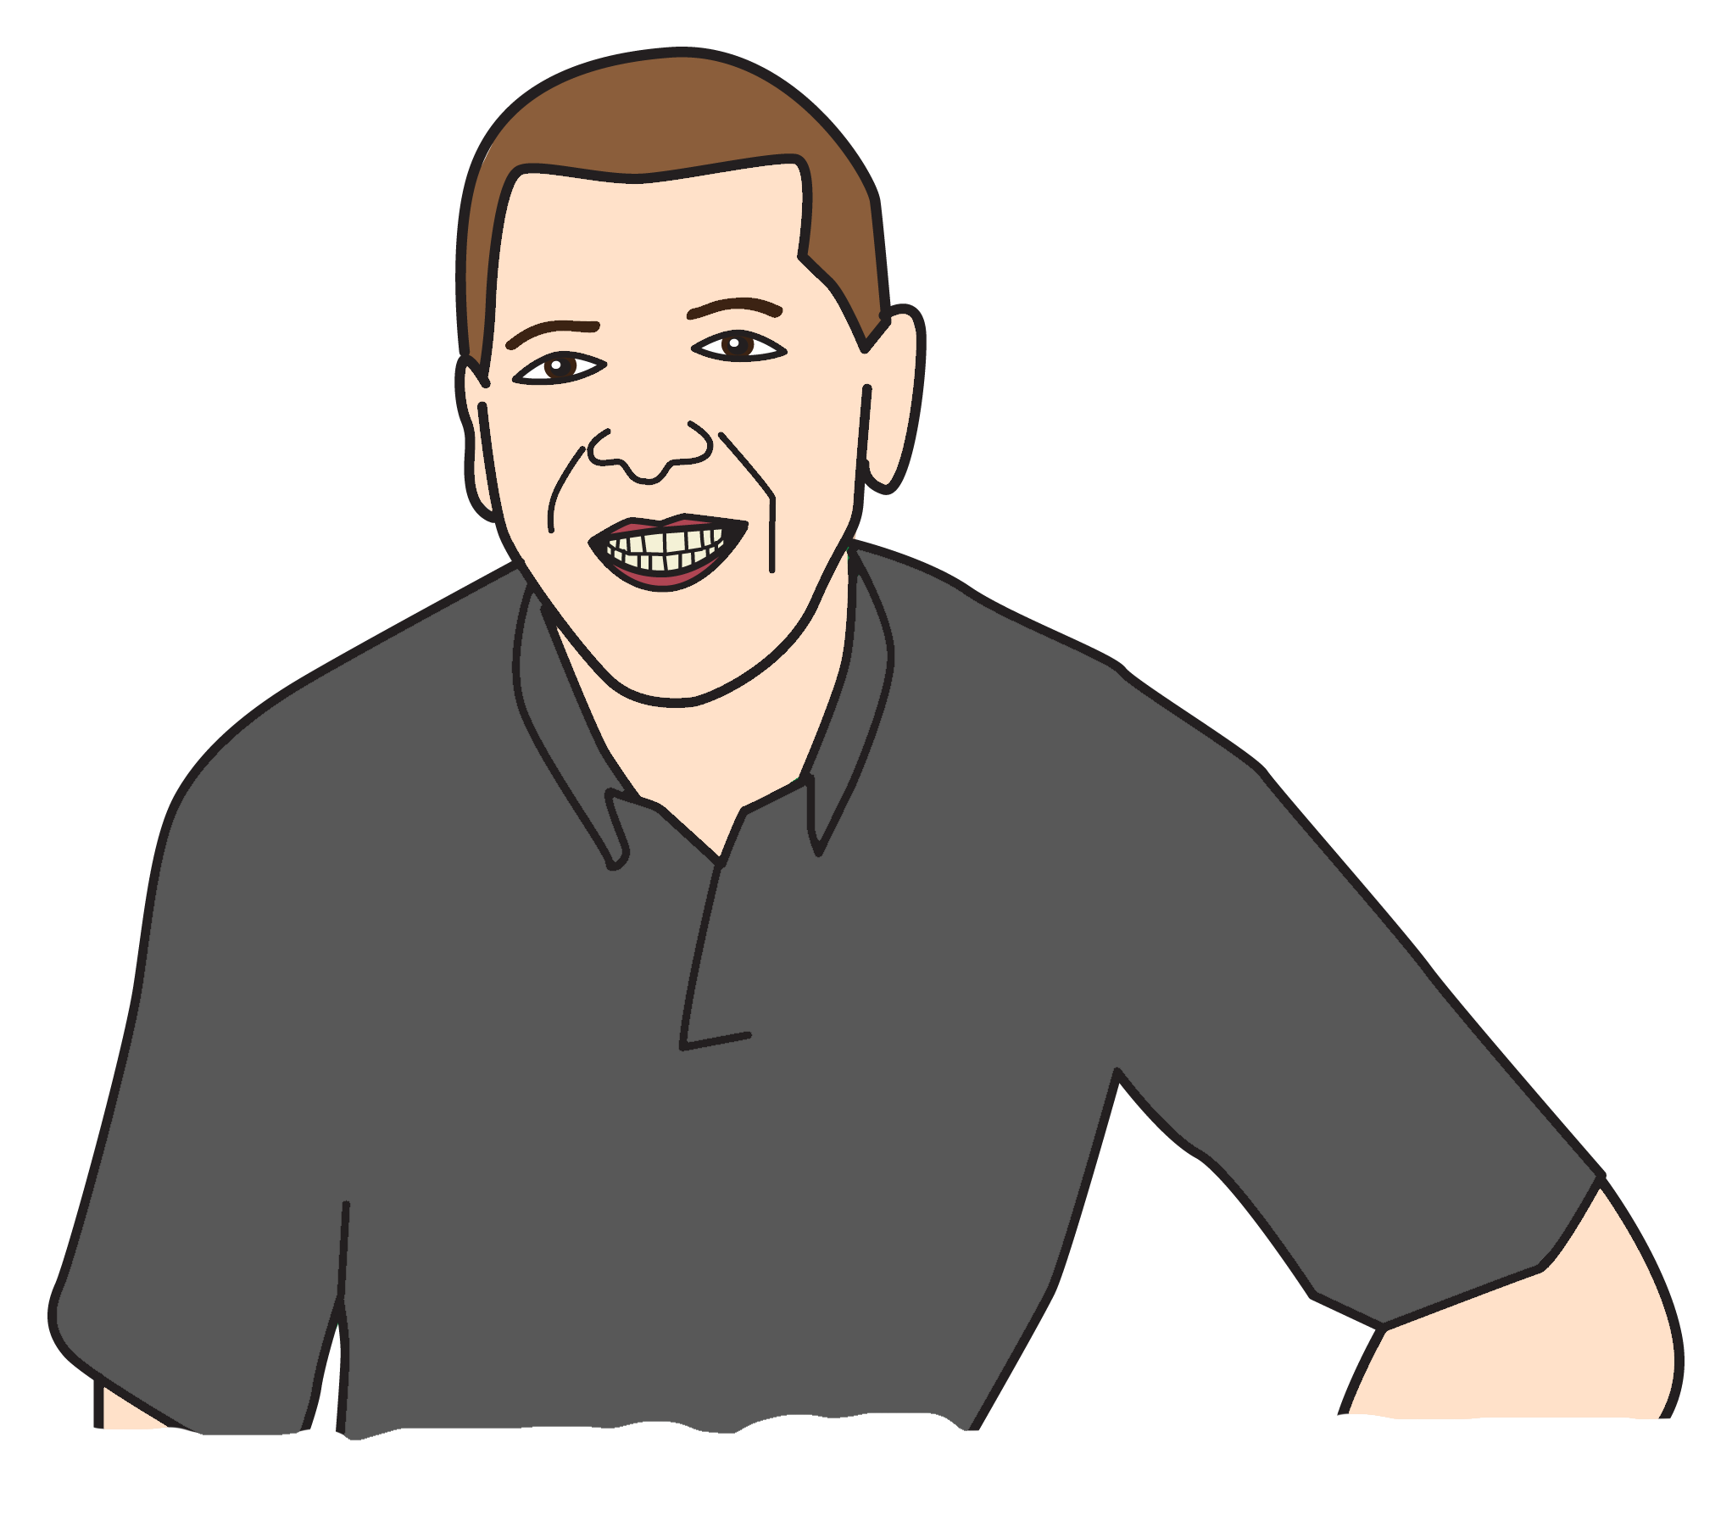

You choose who comes to your home.

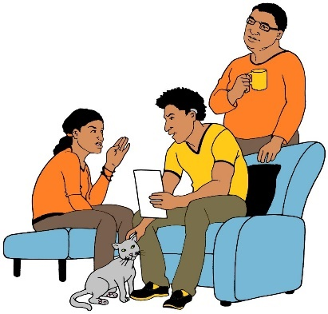
You choose when people can come.
You choose what you do with them.

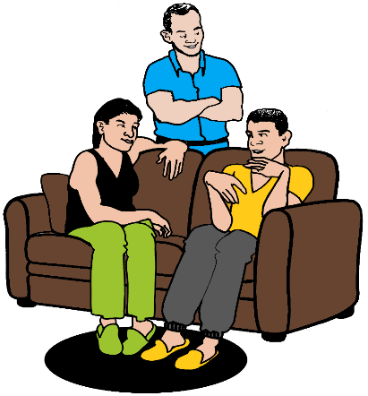
You must feel safe at home.
You may live with house mates.
You may have staff.
They listen to what you say. They treat you well.

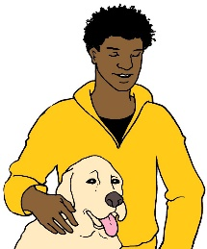
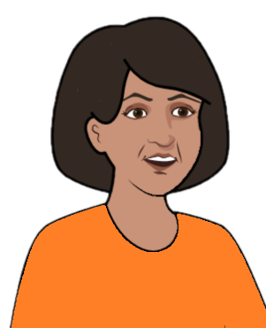
- You have the right to make choices
You can choose who you live with. It may be
- your mum
- your pet
- a house mate.


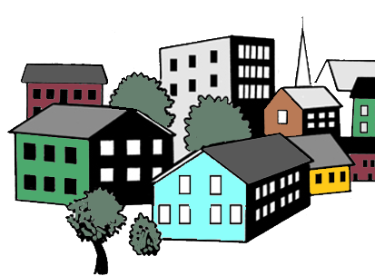
You can choose where you want to live. Like
- in the city
- in a small town.

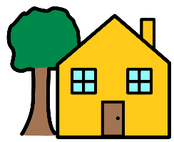
You can choose to live
- in a house with a garden
- in a flat.


- You have control
You can choose your home.
And
You can choose the staff to help you.

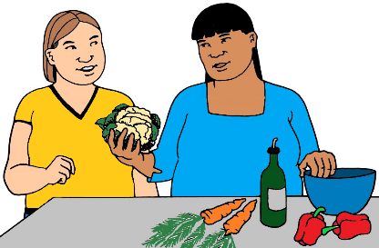
Staff may help you
- cook
- shower
- dress.


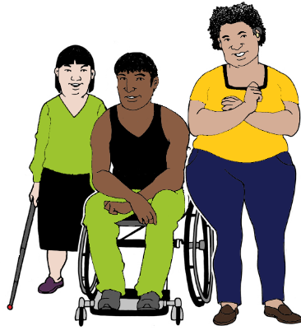
You may live with other people.
Each person has a disability.
You may call it a group home.
A disability service owns your home.

But
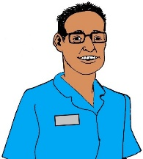

Your staff can be from a different service.


You may want to change where you live.

You can keep the same staff.

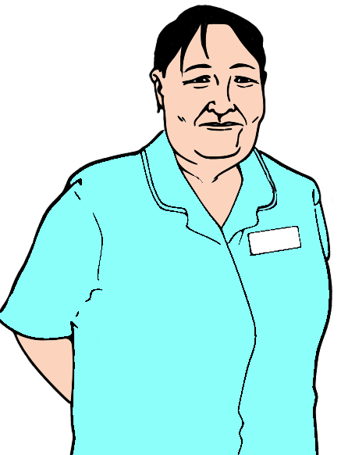
There may be a problem with your staff.
You can get new staff.

But

You do not need to leave your home.

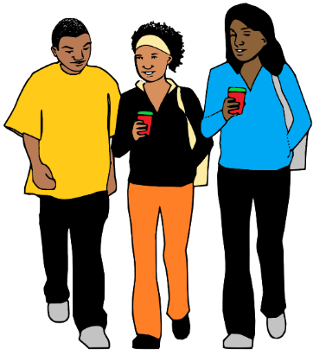
- You are part of your community
We call it inclusion. You can meet with
- your friends
- your family.

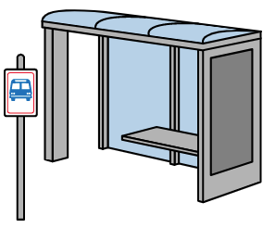
It is easy to get to
- a bus stop
- the shops you use
- places you go each day.


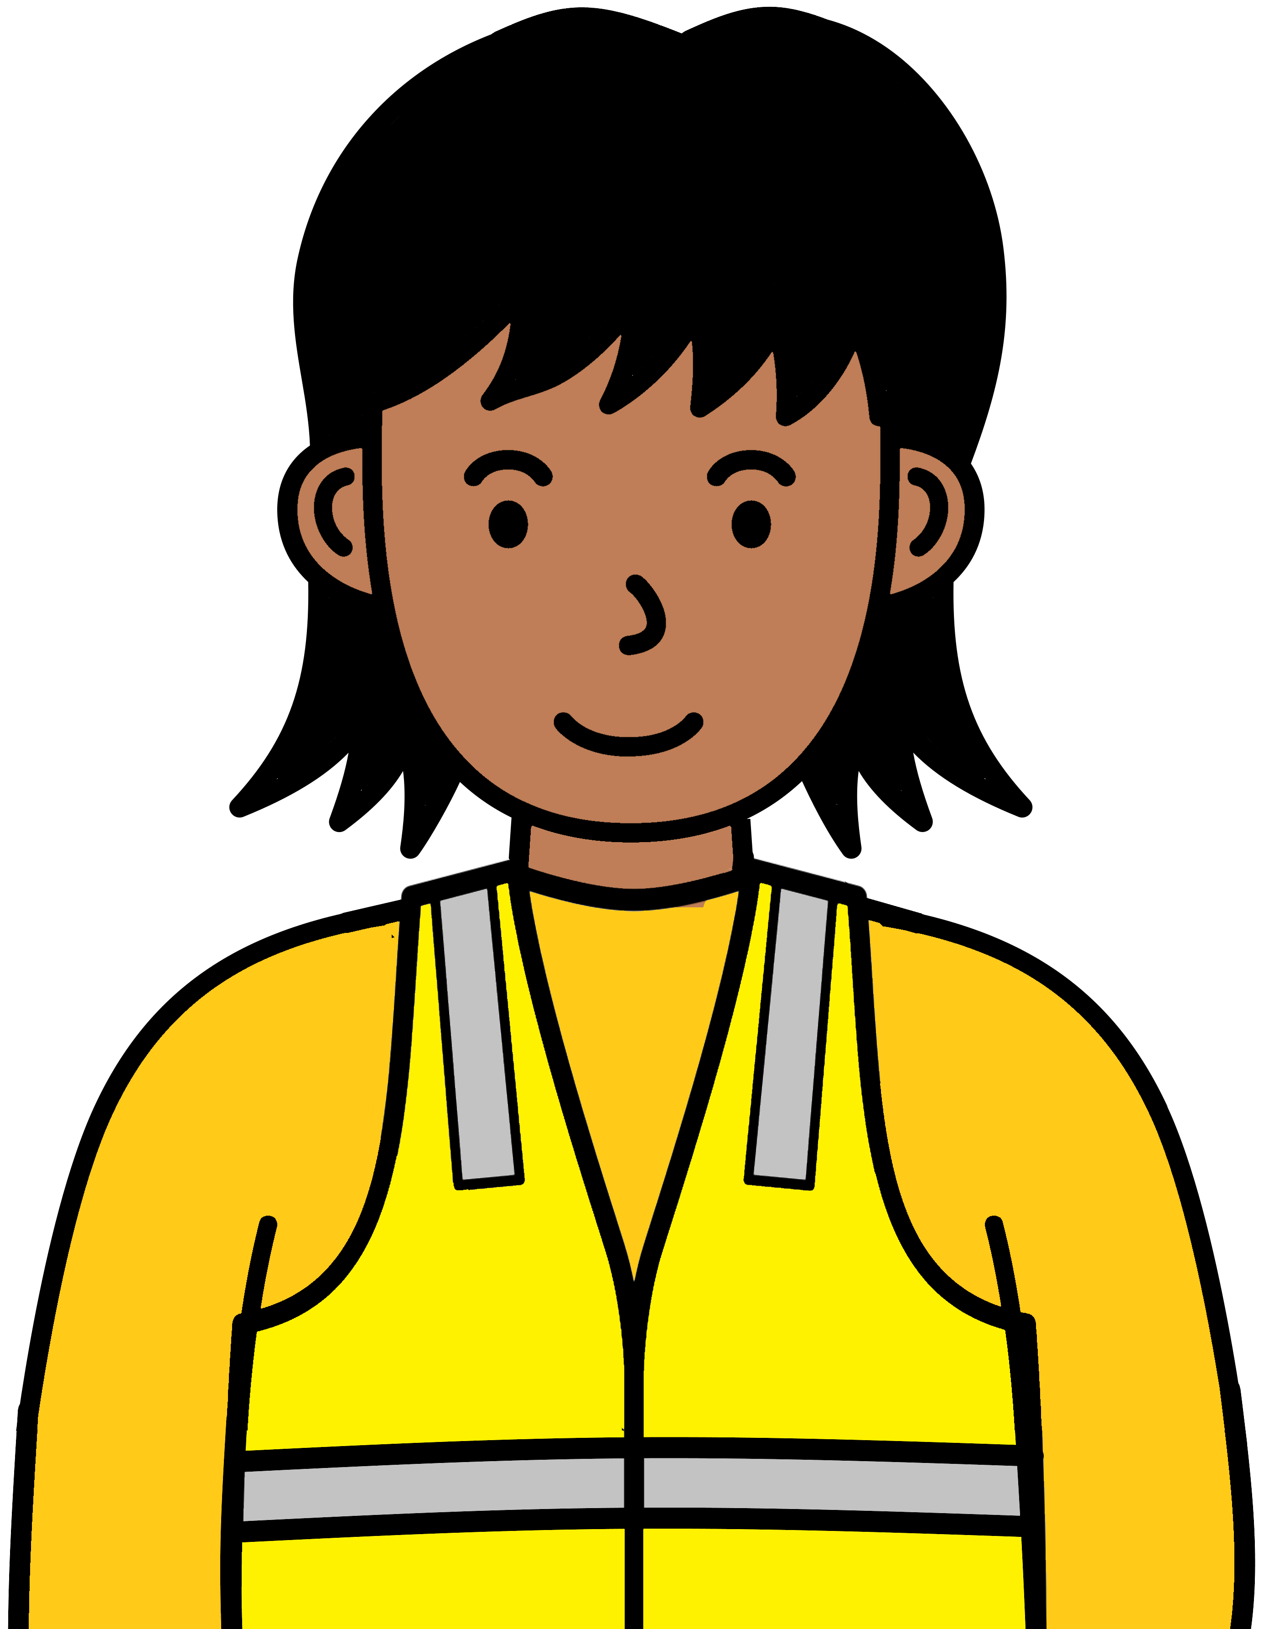
It is easy to get to
- your work
- your study.



You have rights when you
- rent a home
- rent a room.

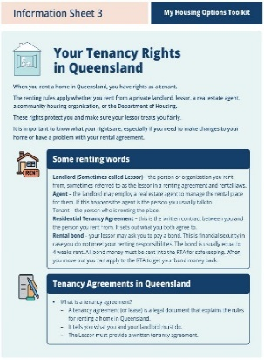
Read Your tenancy rights in Queensland.
It is part of our Toolkit.

You can go to Building Block 1.
Make a start. Your home now.

QDN wrote this book


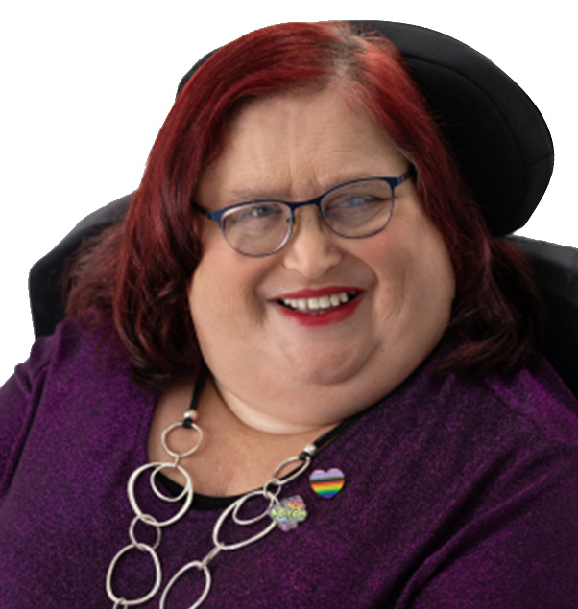
Lots of people helped. Like
- Karin Swift
- Uncle Willie Prince

and

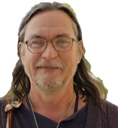

- Nigel Webb
- Grant Higham.

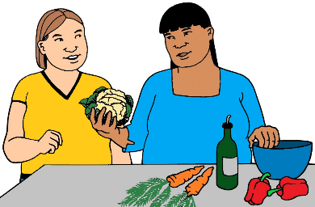
More people helped write the book. They work in
- places that help you in your home
- places that help you speak up
- places that have homes you can live in.







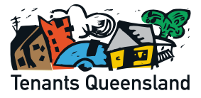
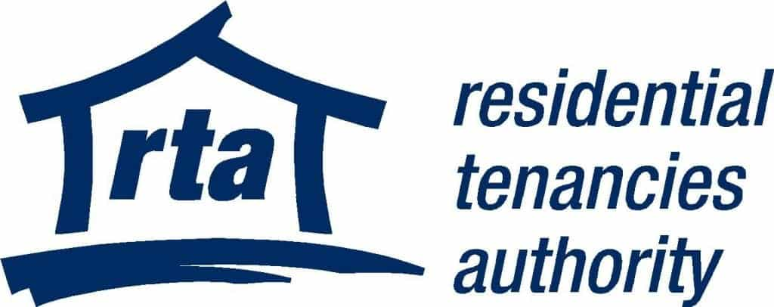








Gary Matthews helped to write the book.
Gary died. It was before we finished this book.
Gary worked hard at QDN. He wanted
people with disability to have good homes.
We thank Gary for all his work. We miss Gary.

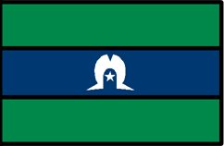

We thank
- Aboriginal people
- Torres Strait Islander people.

You want to know more

You can talk to QDN.



Call 1300 363 783.

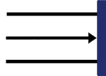
This is the end of this part.

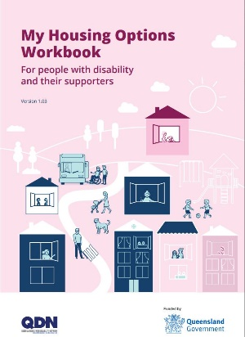
These books are based on the My Housing Options Workbook for people with disability and their supporters. 2025.
QDN and the Queensland Government wrote it.

Images
We can use the images in these books.
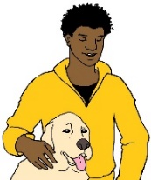
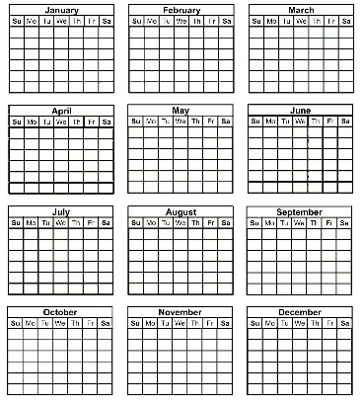
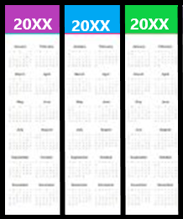
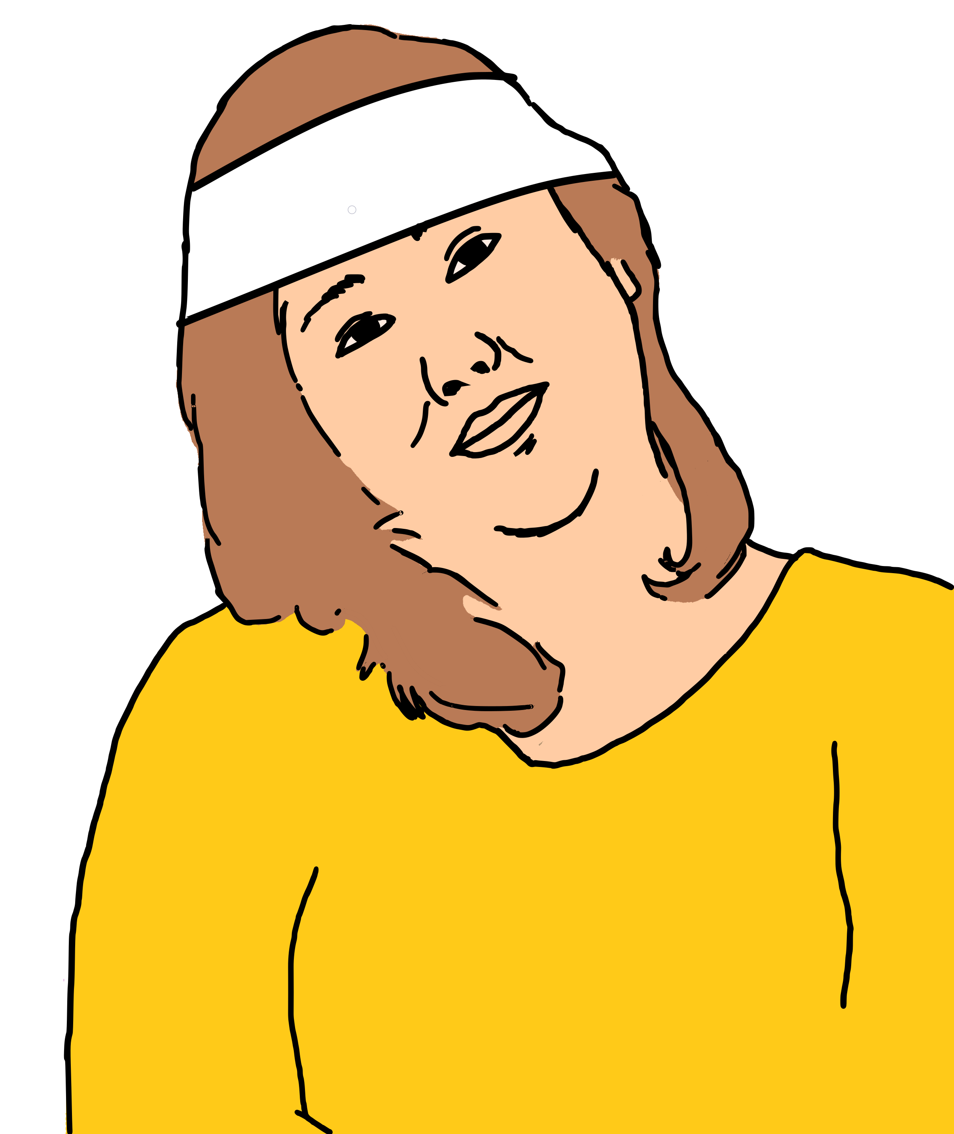
They are from
- CHANGE changepeople.org
- Global Symbols
- Inspired Services
- iStockPhotos
- The Noun Project
- Printablee
- Tobii Dynavox
- 123rf.

Photos
The photos are from QDN. The people in the photos said we can use these photos.

Logos
We used some logos.
They said we can use them in this work.

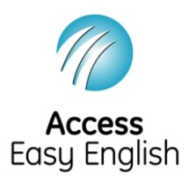
Access Easy English helped QDN write the Easy English. July 2025.

