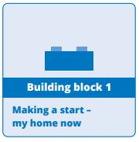

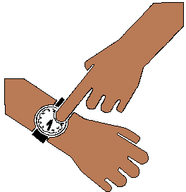
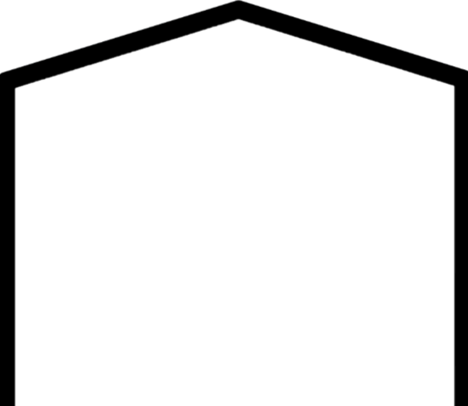
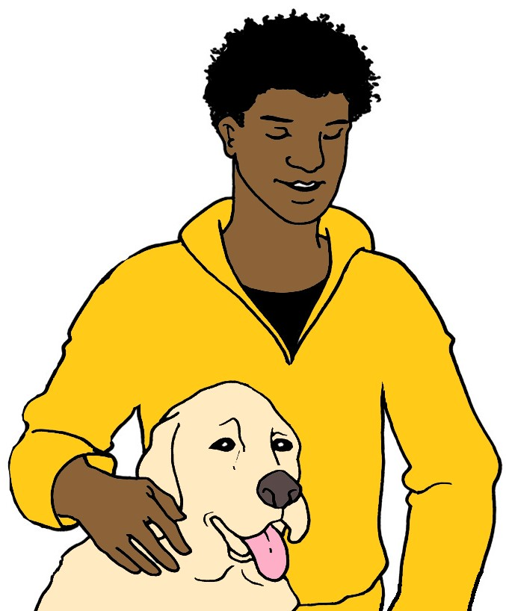

Building Block 1.
Make a start.


Your home now.
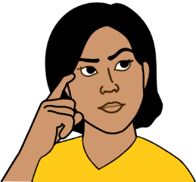
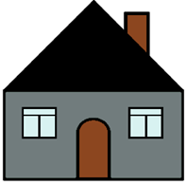
Think about your home now.
This helps you start your plan.



Think about
- what you like
- what you may want to change.

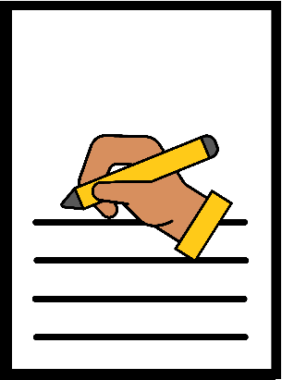
There are lines you can write on.
You can draw a picture.
You may want to paste in photos.

What do you like about your home now?
It may be
- you live with your pets
- you live near a park.


Write what you like.

___________________________________________________________________________________________________________________________________________________________________________________________________

What do you not like? It may be
- you live a long way from work
- you live a long way from your friends
- the bus stop is a long walk from your home.

Write what you do not like.

___________________________________________________________________________________________________________________________________________________________________________________________________

Some things may be OK.
You may want some things to change.

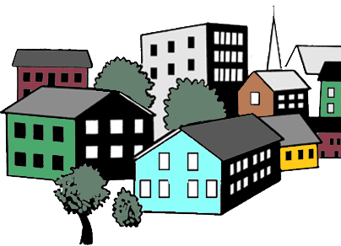
You may live in a big town.
You want to stay in this town.

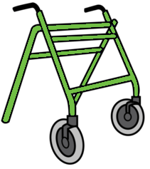
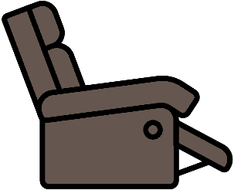
You may need more space.
It is for the things you use. Like
- your new chair
- your walking frame.

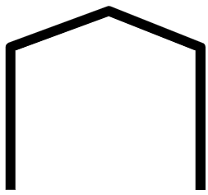

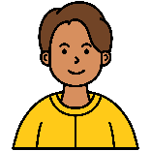
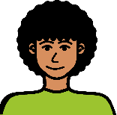
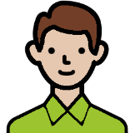

You may live with lots of people. Like 5 people.
You want to live with less people.
Like 1 other person.

Write what you want to change.

___________________________________________________________________________________________________________________________________________________________________________________________________

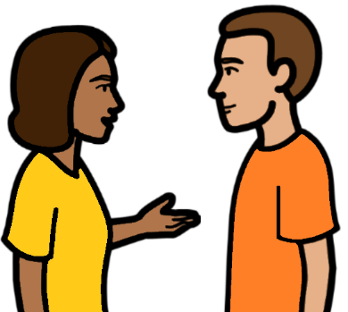
What will you do next?
You may want to talk to your friends.
They may live in different sorts of homes.
You can ask them about it.

____________________________________________________________________________________________________________________________________________________________

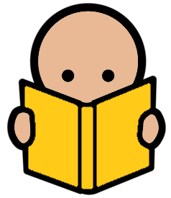
You want to know more


There are places you can talk to. Like a
- disability service
- housing service.
They can help you find a home.

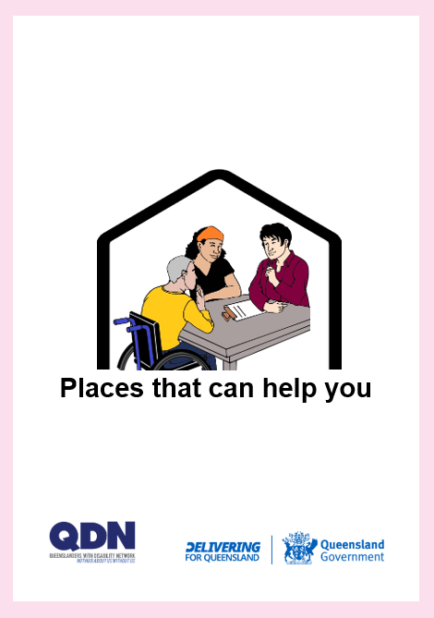

Read Places that can help you.

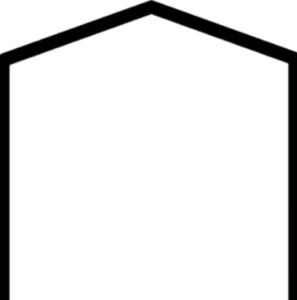
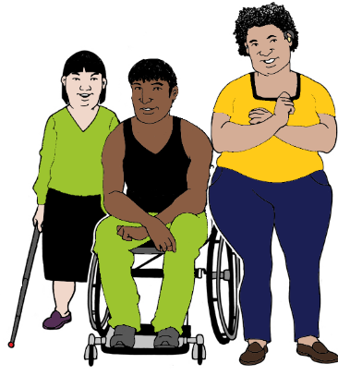
You want to know about different sorts of homes.
Like homes for people with disability.

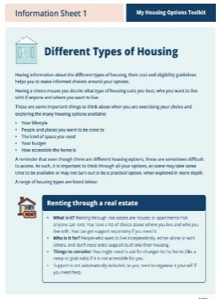
Read Different types of housing.
It is part of our Toolkit.

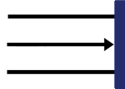

This is the end of this part.

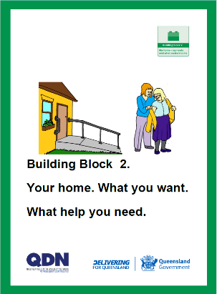
You can go to Building Block 2.
Your home. What you want. What help you need.

