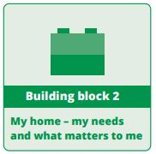
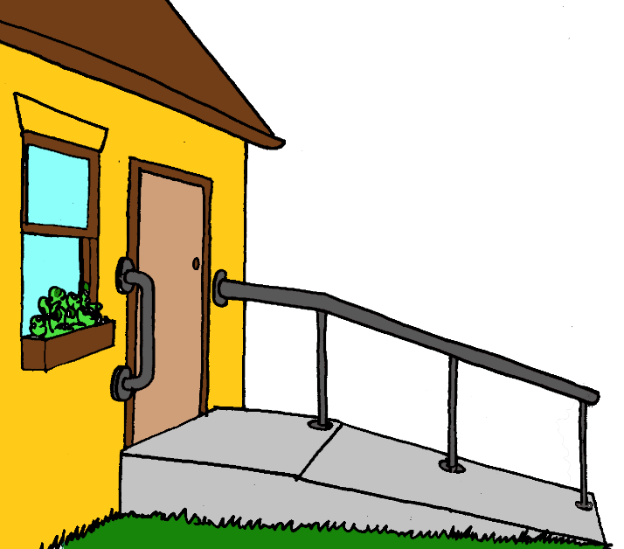
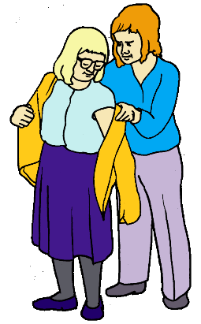

Building Block 2.
Your home. What you want. What help you need.


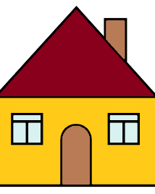

You want a home that is right for you.

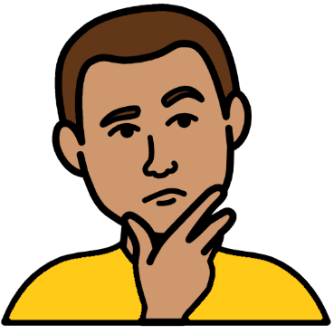
This book helps you think about
- what sort of home you want
- where you want to live
- who you want to live with
- what you need in a home. Like a ramp.
Go to page 4.

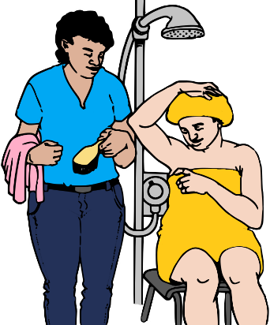
It helps you plan the staff help you may need.
Go to page 16.


Mark the boxes that are right for you.

And

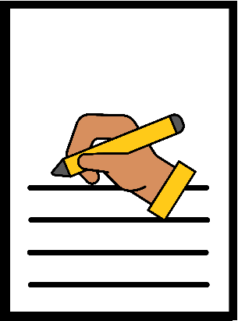
There are lines you can write on.
You can draw a picture.
You may want to paste in photos.

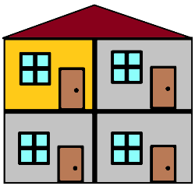
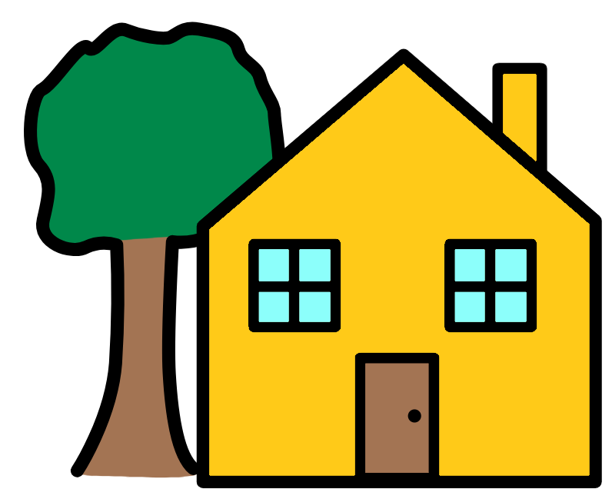
What home do you want?

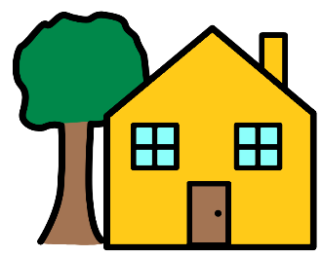
You want to live
- in a house. It may have a garden

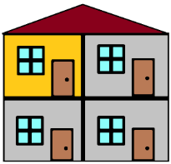
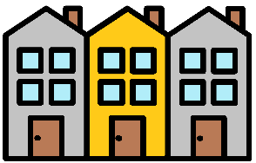

- in a unit. It may be a town house


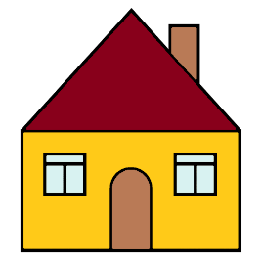
- in a home you rent.
You have to pay some money.
The government may own your home. We call it public housing.
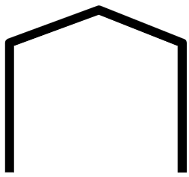

You want to live by your self.
We call it independent living.
Staff may come to help you at home.


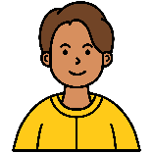
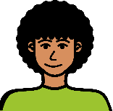
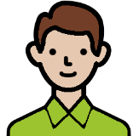

You want to live with other people.
We call it shared living. Staff may help
  - you
  - other people in your home.

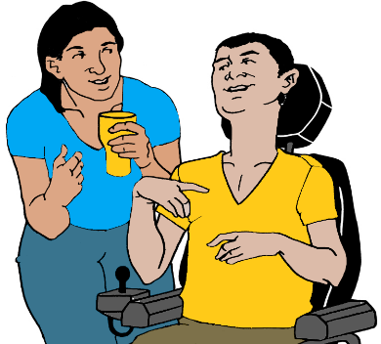
You want to live in a home.
It is for people who need lots of staff help.
It helps you to stay
  - safe
  - well.
You must have an NDIS plan.
The NDIS call it an SDA.
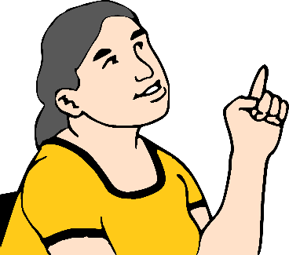
You may want a different home.


Write it here.

_____________________________________________________________________________________________________________________

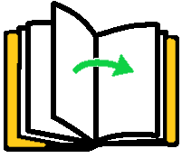

Go to the next page.

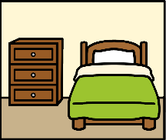
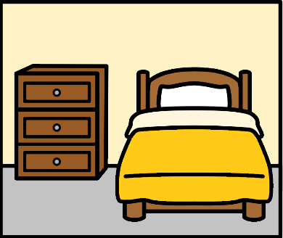
How many bed rooms?

You need
- 1 bed room

- 2 bed rooms

- more than 2 bed rooms.
Like 4 bed rooms.

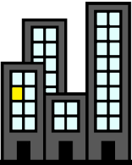
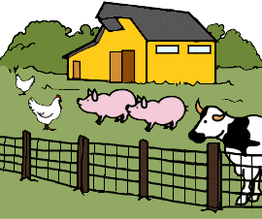

Where will you live?

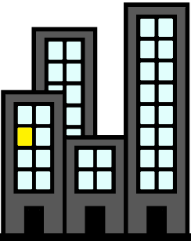

In the city. Like Brisbane

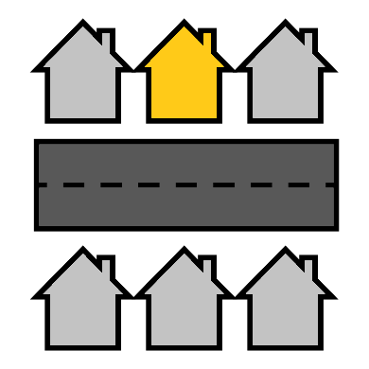

Near the city. We call it a suburb

In the country. You may want to live
- on a farm
- in a small town.

How much can you pay?

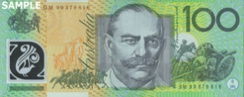


- $ 150 each week


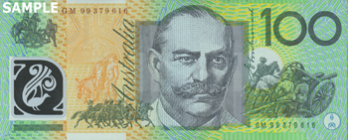

- $ 250 each week


- $ 400 each week

or
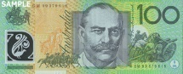
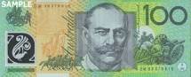
- more than $ 400 each week.
Like $ 500.

Write how much you can pay.

_________________________________

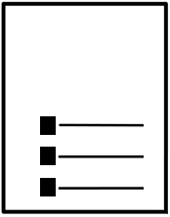
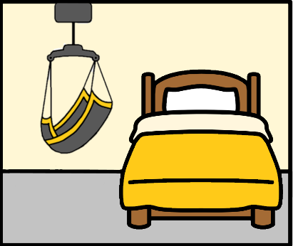
What does your home need?

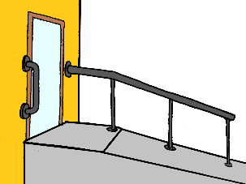
You need
- a ramp
- a lift

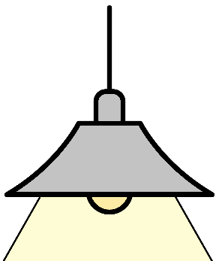

- soft lights

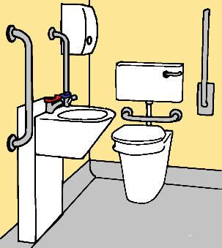
- rails in the bath room
- a shower you can use

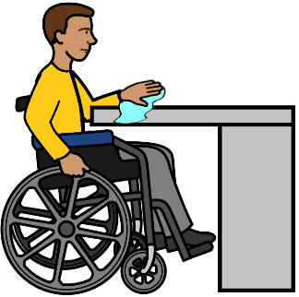

- low benches.

Your home may need more things.
They are for your disability. Like a hoist.


Write it here.

______________________________________________________________________________
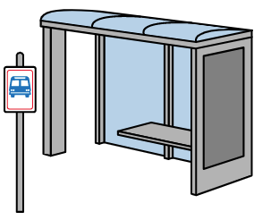
You want to live close to
  - a bus stop
  - a train station

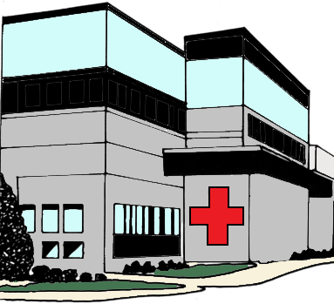
  - hospital
  - your doctor

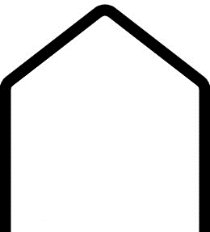
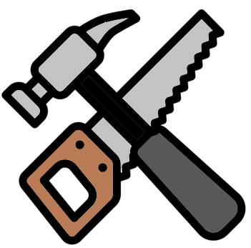
  - places you go. Like the Mens shed
  - places that help you.
Like they help with your NDIS plan

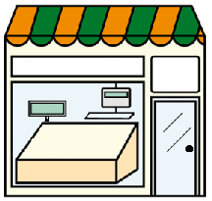

  - the shops.
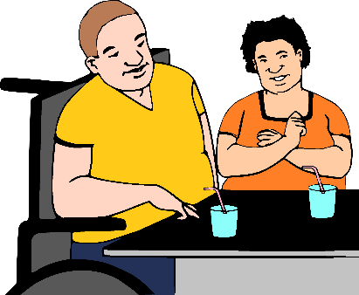
You want to live close to
  - friends
  - family
  - groups you go to. Like your art group

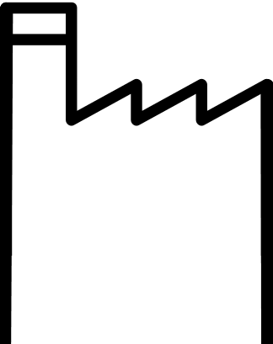
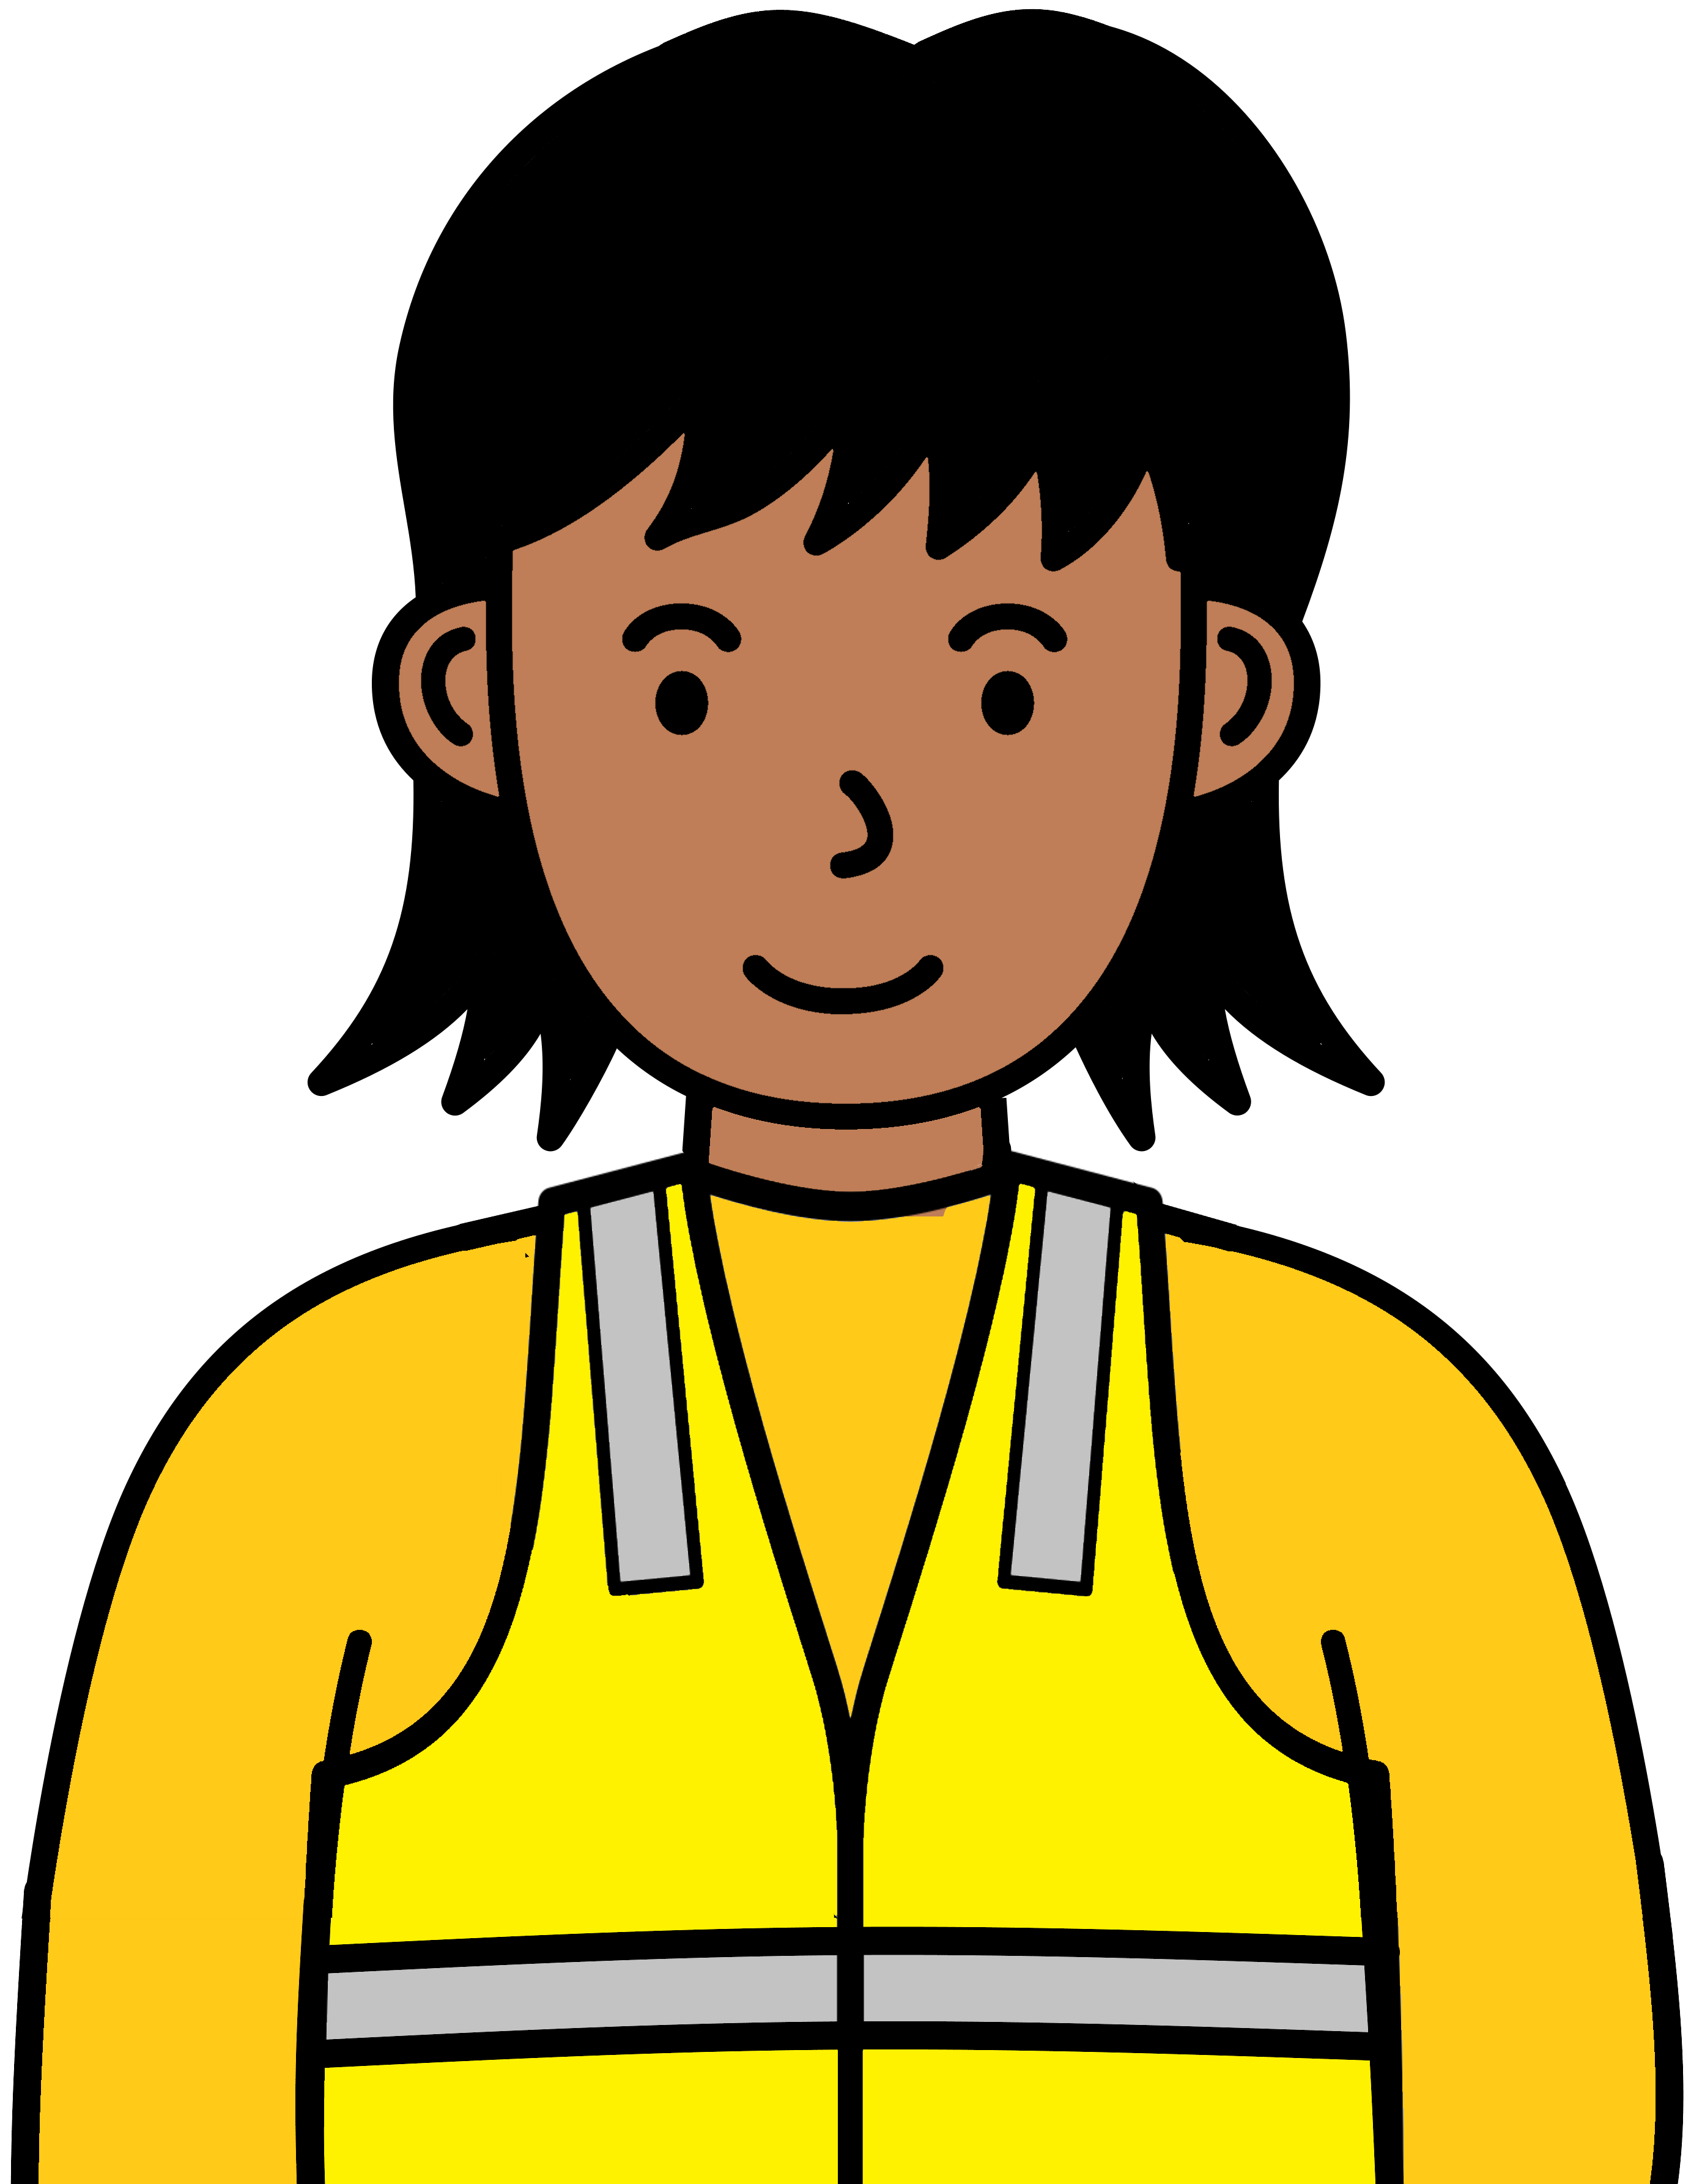
  - work
  - study
  - day service.

You may want to live close to more things.
Write them here.

_____________________________________________________________________________________________________________________

You want to know more



Call Housing Hub. 1300 616 463.

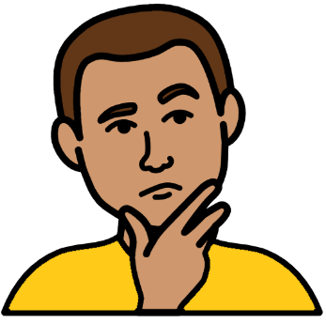
They can help you think about
- what you want for your home
- what you need for your home.


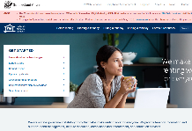
You want to know how much rent costs.
Go to www.rta.qld.gov.au.
Get help to use the Rent Rate Finder.
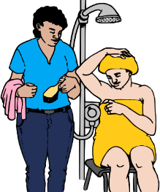
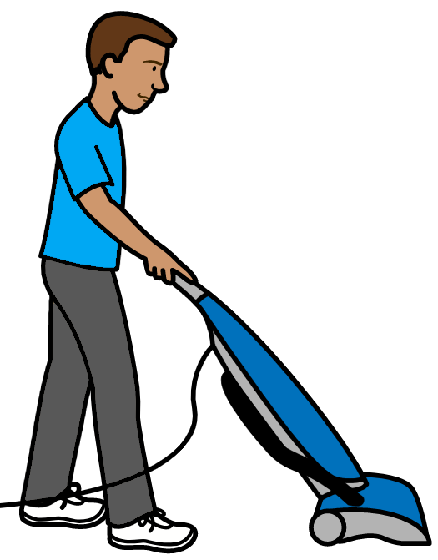
What help will you need?

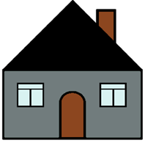
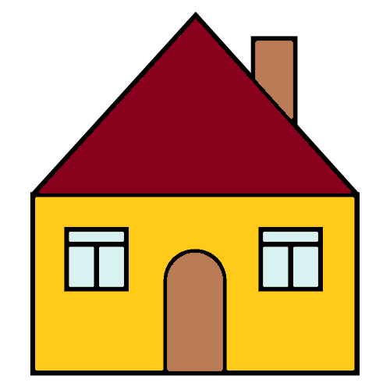
You move to a new home.
The help you need can change.

Think about
- who will help you
- who you want to help you.

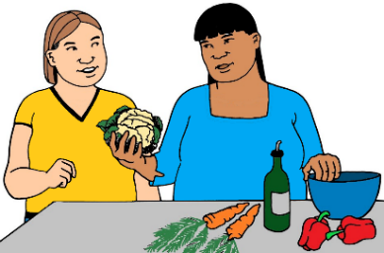
Think about the help you need.
You may need staff help.

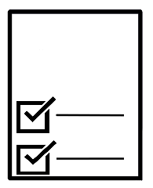
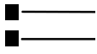
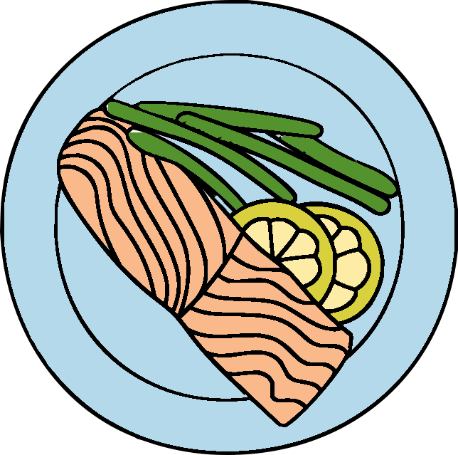
Will you need help to

  - plan what you will eat

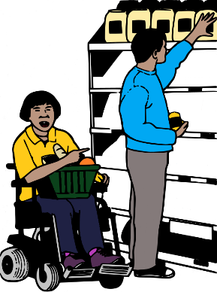

  - buy food

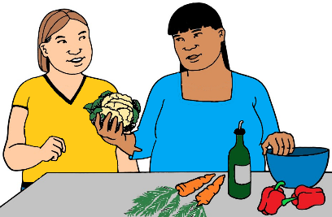

  - cook meals?

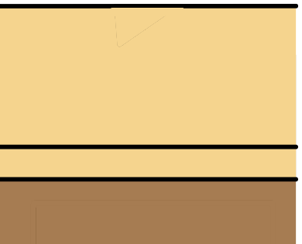
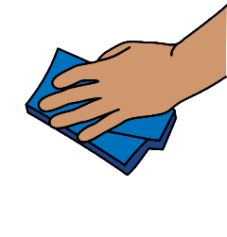
Will you need help to
  - clean your home. They are small jobs.
Like wipe the kitchen bench

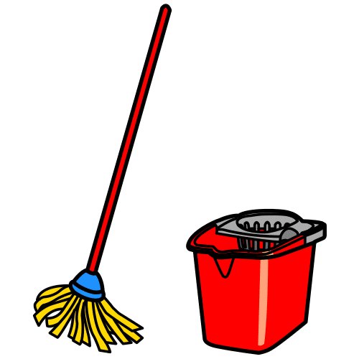

  - clean your home. They are big jobs.
Like mop the floors

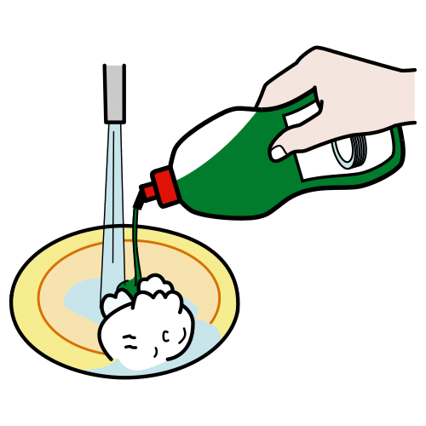

  - wash your dishes
  - wash your clothes

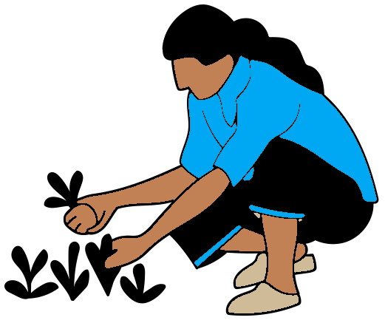
  - look after the garden
  - cut the grass?
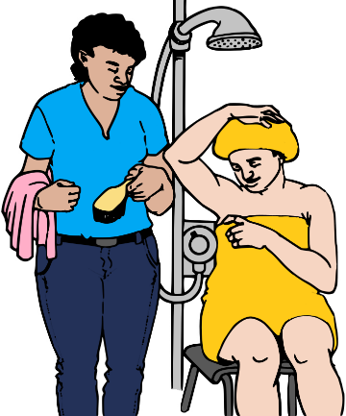
Will you need help to
  - shower

  - dress

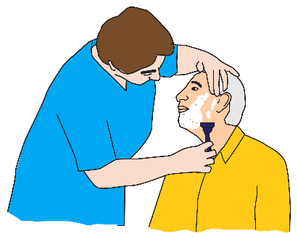
  - shave
  - clean your teeth
  - wash your hair?



Will you need help to

  - take your pills
  - know when to take your pills
  - know when you need more pills?

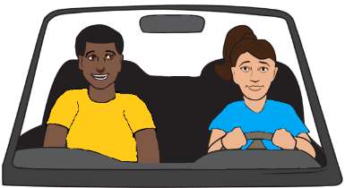
Will you need help to go places? Like
  - a person takes you in a car
  - a person helps you take the bus.

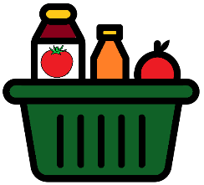
Will you need help with money?
Like help to
  - pay for your food
  - know how much money you have
  - make a money plan.


Will you need help to stay well? Like

  - choose food that is good to eat
  - move your body
  - meet other people.

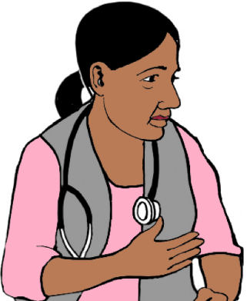
You change where you live.
Will you need a new doctor?
You can choose to keep the same doctor.
This is OK.

You may want more health help. Write it here.

_____________________________________________________________________________________________________________________
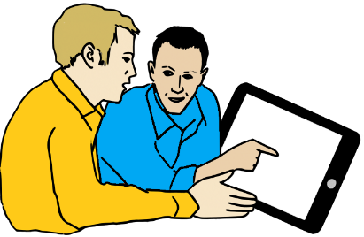

More help you may need

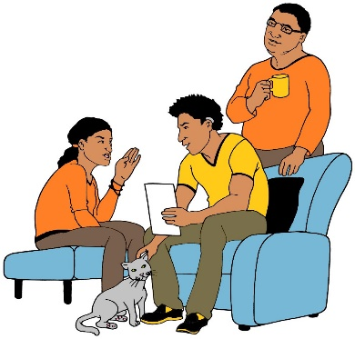
Will you need help to

  - talk to your family

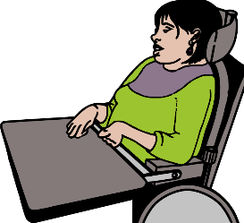
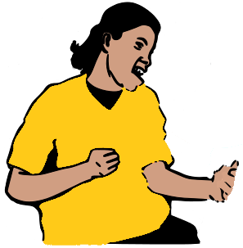
  - talk to your house mates


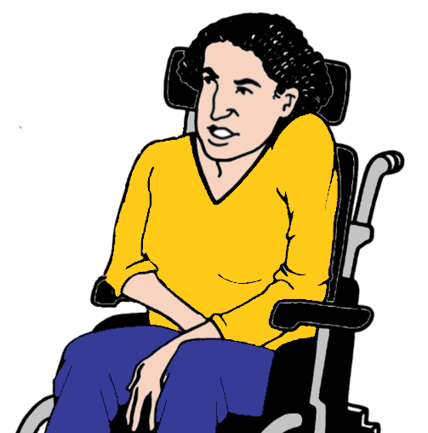
  - talk to people you do not know?
Like at the shops.

Will you need help to

  - use your iPad
  - use your phone
  - use the internet? Like send emails.

You may want more help. Write it here.

_____________________________________________________________________________________________________________________

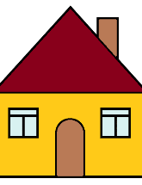


You rent your home

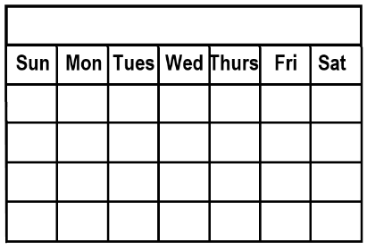
Will you need help to

  - pay your rent on time

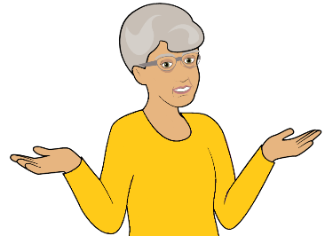
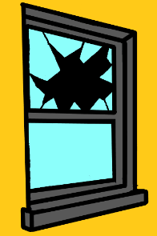
  - know what to do when things
go wrong? Like a window breaks.

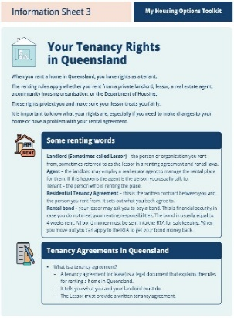
Read Your tenancy rights in Queensland.
It is part of our Toolkit.

You may want more help. Write it here.

___________________________________________________________________________________________________________________________________________________________________________________________________

Think about all the help you need.
Will you need help
  - each day

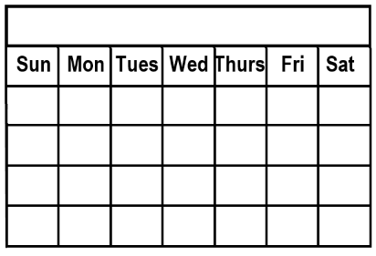
  - some days. Like 3 days a week

  - only some of the time?
Like 3 days a month.

Or
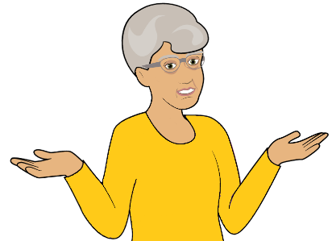

  - you do not know.
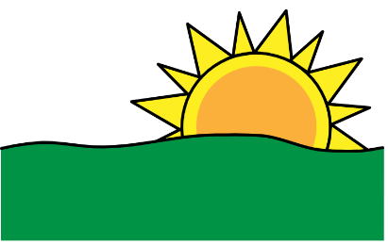
What time do you need help? It may be

  - in the morning

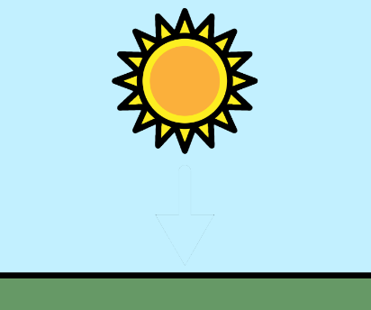

  - in the afternoon


  - at night

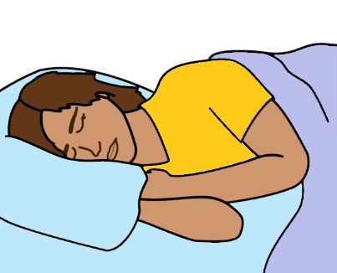

  - over night. It is while you sleep.

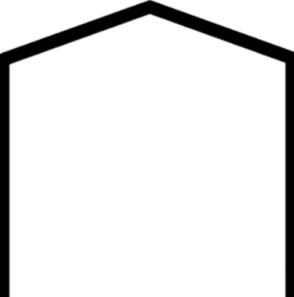
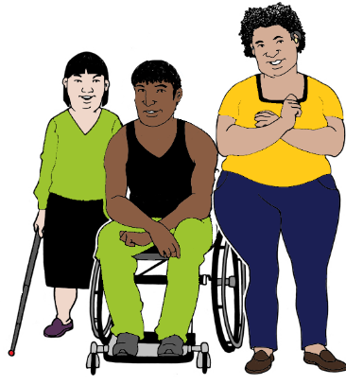
You plan to live with other people.
There are staff to help.

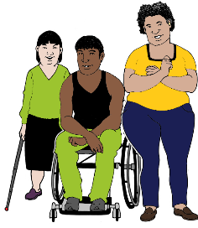
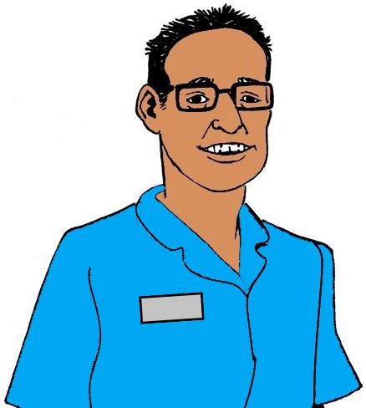

Is it OK to share some help?

or
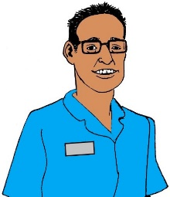


Will you need your own help?

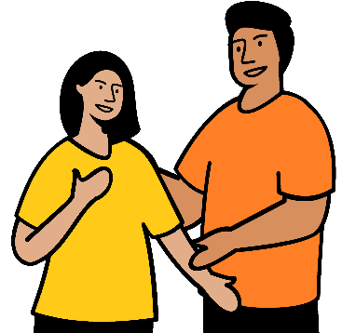
Who helps you now? They are not staff. Like
- your brother
- your friend.

Write who helps you now.

_____________________________________________________________________________________________________________________
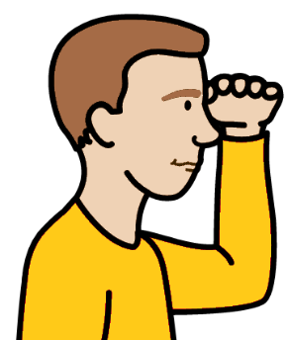
What do you need to do next? Like
- look for new help
- talk to people you know.

Write what you will do next.

_____________________________________________________________________________________________________________________

You want to know more
It is about help you can get at home.

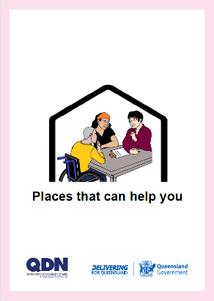

Read Places that can help you.

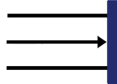
This is the end of this part.

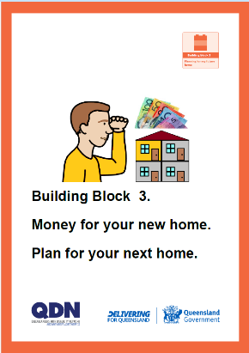
You can go to Building Block 3. It is about
  - Money for your new home.
  - Plan for your next home.

