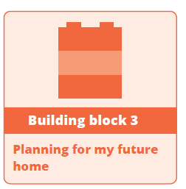
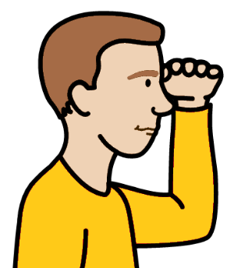
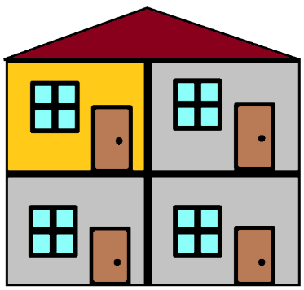


Building Block 3.
Money for your new home.


Plan for your next home.
You want to plan for where you live.
You need to look ahead.


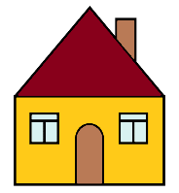
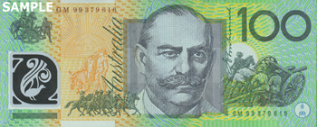

You need to plan what money you will need.
Go to page 4.

And

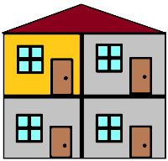
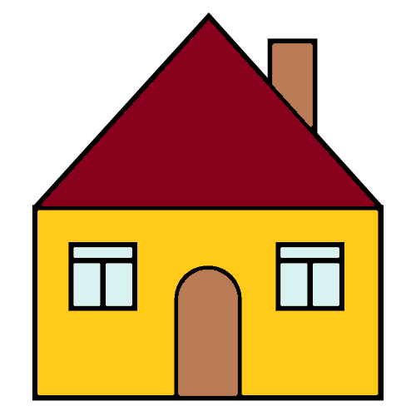
You can plan for more changes.
Like in 5 years. You may
- want a different home
- need a different home.

Or

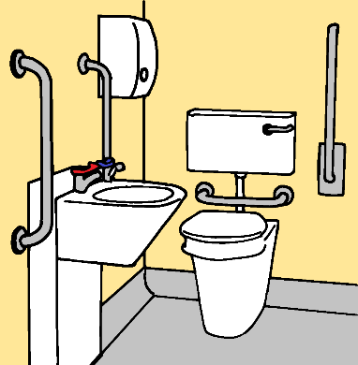
Your home may need changes.
Like you need hand rails in the bath room.
Go to page 16.


Mark the boxes that are right for you.

And

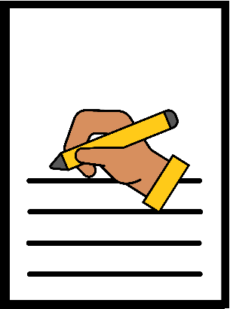
There are lines you can write on.
You can draw a picture.
You may want to paste in photos.

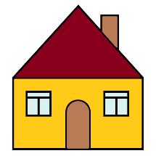
Money you need for
your home

You want a new home.
You need to plan what money you need.

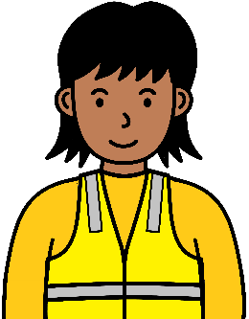

Think about the money you get. It may be from
- your job
- Centrelink. Like you get a disability pension
- your family.

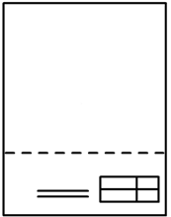

Think about things you must pay for.
You must pay for your home. It may be rent.

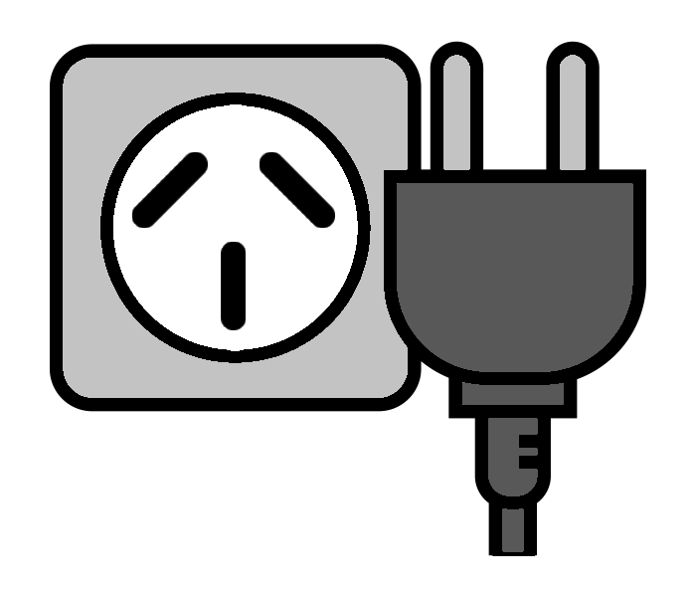

You must pay your bills. Like the power bill.

Do you have a plan for your money? It is
- to rent a home
- to buy a home.



Yes
No.

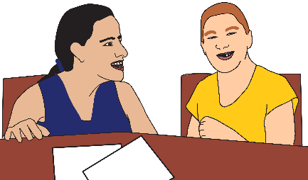

Do you need help to make a plan?

Yes
No.

You may rent a home. You may rent a room.
You may buy a home.
Where will you get money for your home?

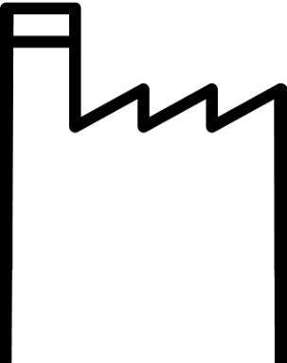

- from your job

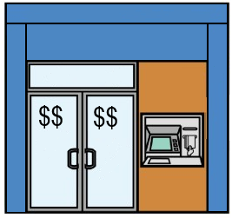
- you saved some money.
It is in your bank.
You will use some of this money.

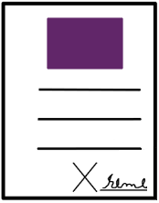

- you will use money in your NDIS plan.
Your home must be in your plan.


- from Centrelink

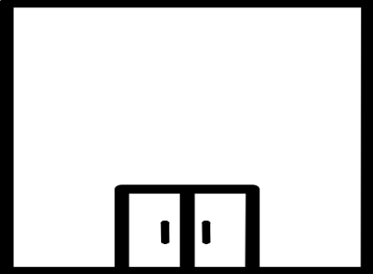


- from the Queensland Government.


You may get money from a different place.
Write it here.

_______________________________________
_______________________________________

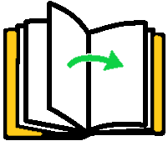

Go to the next page.

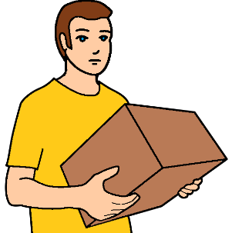
Before you move in


You need to pay money. It is before you move in.
You may need to pay 2 weeks rent.
Like your rent is $ 200 each week.
You need to pay $ 400.
They call it rent in advance.

And

You need to pay more money.
It may be the same as 4 weeks rent.
Like your rent is $ 200 each week.
You need to pay $ 800.
They call it your bond.

Will you have money for
- your bond
- 2 weeks rent before you move in?

Yes
No.

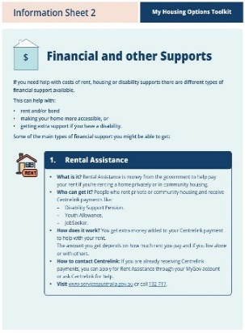
You may get help to pay for this.
Read Financial and other supports.
It is part of the Toolkit.

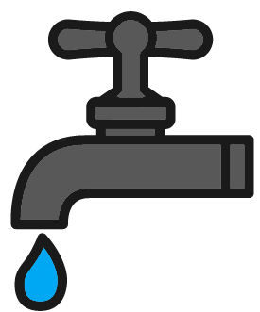
Do you have money for bills? Like you pay for
- water
- power
- gas.

Yes
No.

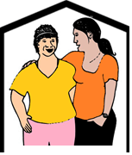
Do you need to live with other people?
They pay some of the rent.
They pay some of the bills.
Yes
No.
You may want to write more about
- your money plan
- things you need to pay for.


Write it here.

___________________________________________________________________________________________________________________________________________________________________________________________________


You want to know more


Call the Queensland Government. 13 74 68.
Ask about help to pay
- your bills
- your bond
- rent before you move in.

You may get more help with money.
Read Financial and other supports.

What do you need to do next?
Like ask for help to make your plan.

Write it here.

__________________________________________________________________________________________________________________________________________________________________________________________________

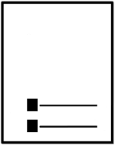
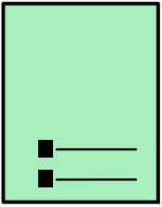
Plan for your next home

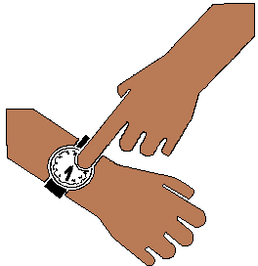
You think about what you need now.

And

You look ahead. Things can change.
Think about what you may need.

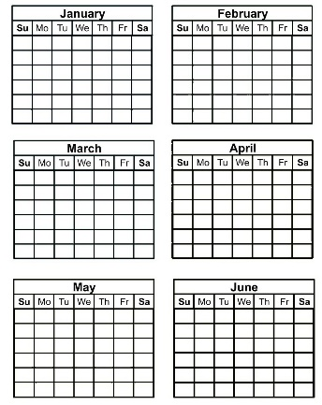
It may be in
- 6 months
- 2 years
- 5 years.

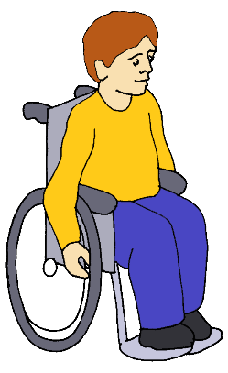
It gets hard to move.
You may need a wheel chair.

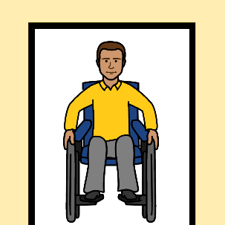
You may need changes to your home.
Like wide doors.

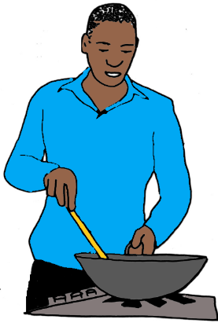
You may want to change your help.
Like staff cook your meals each day.

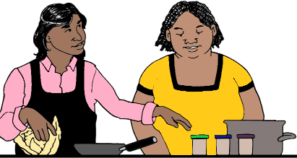
You go to classes. You learn to cook.

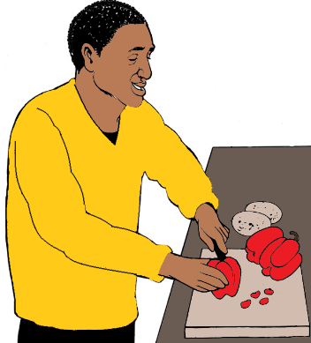
You may not need staff each day.
You can cook for your self.

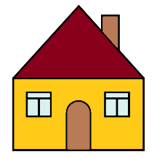
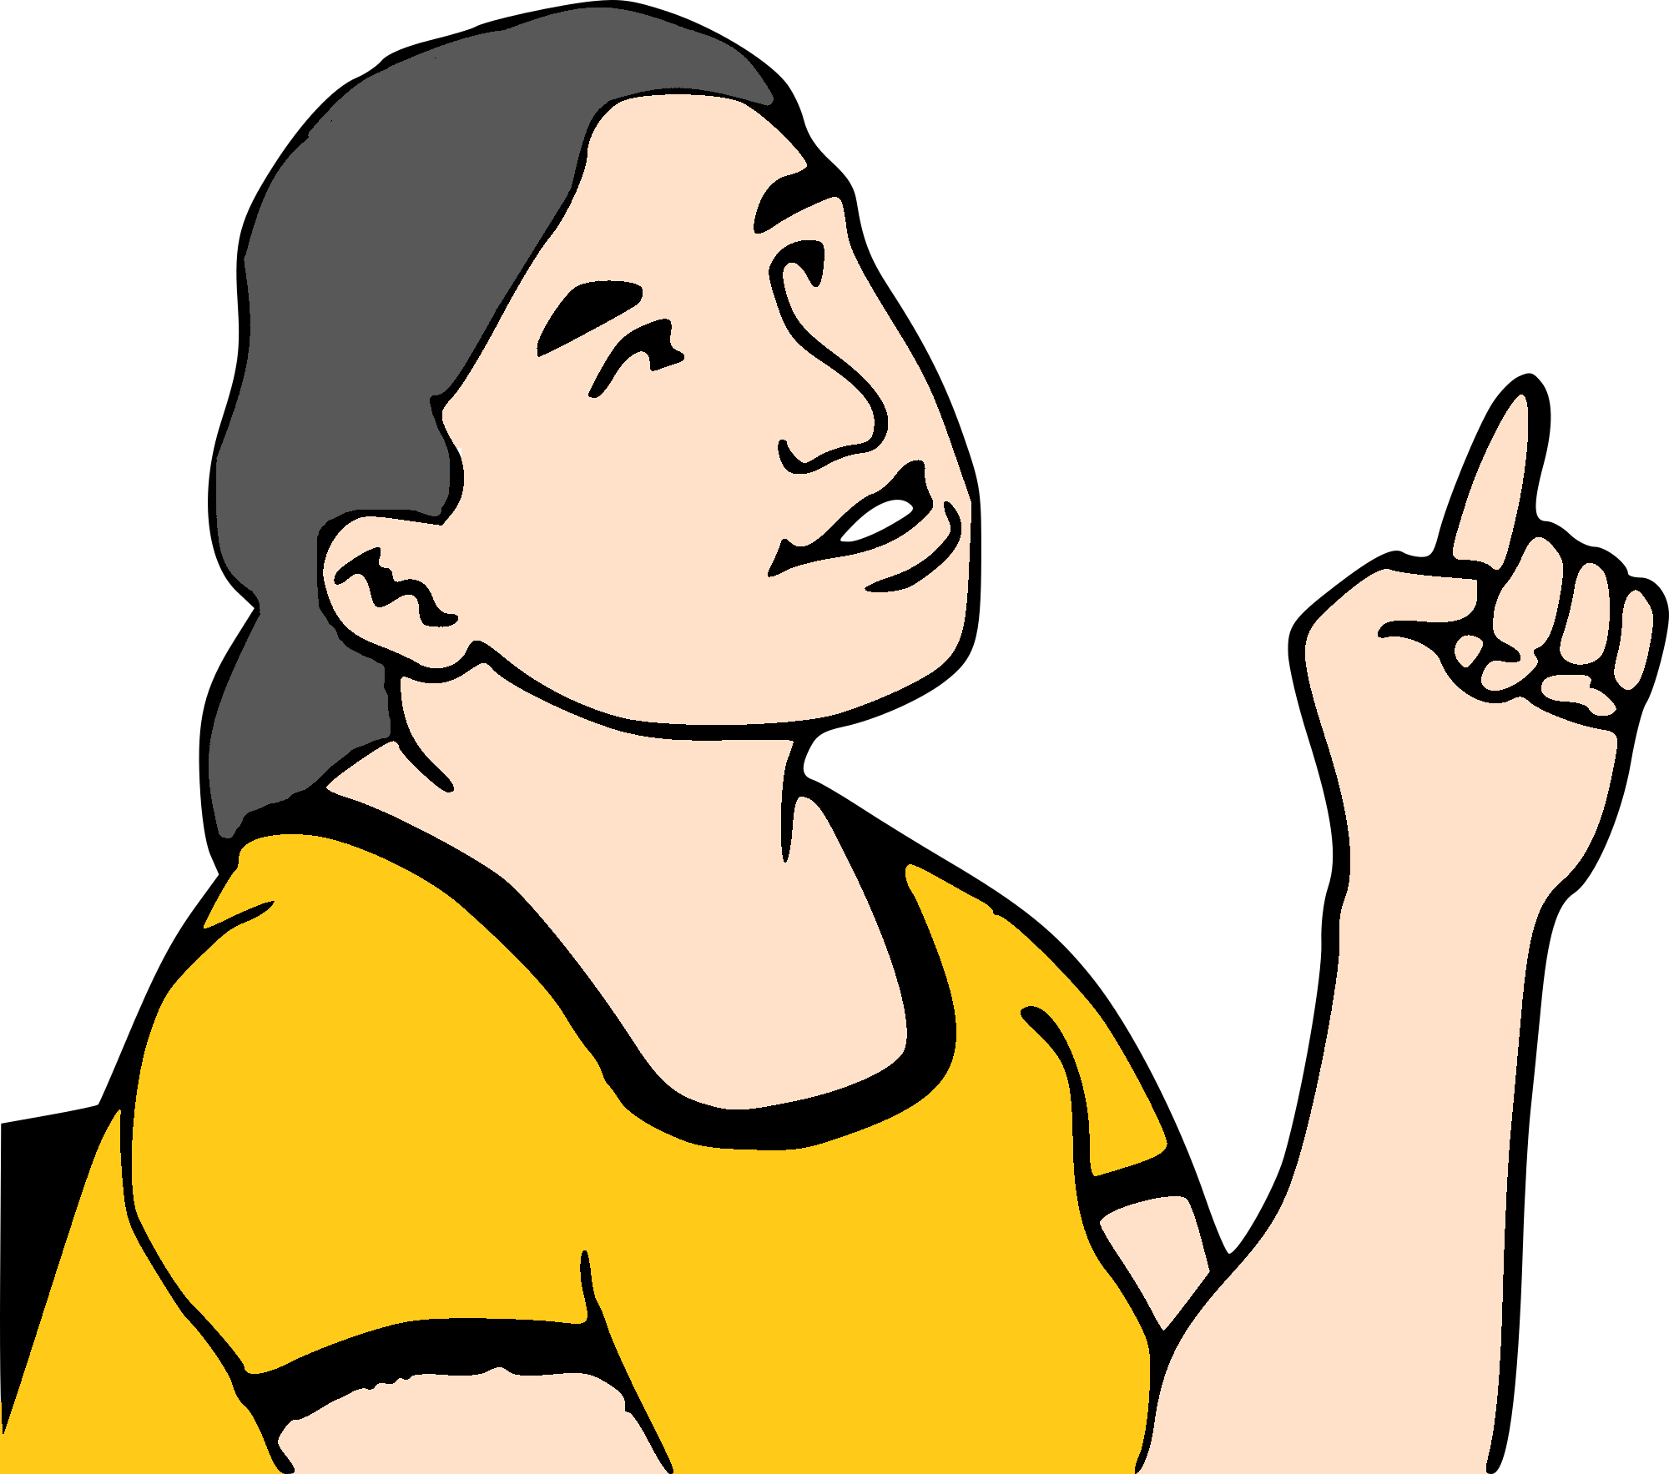
Your next home
How long do you want to stay there?

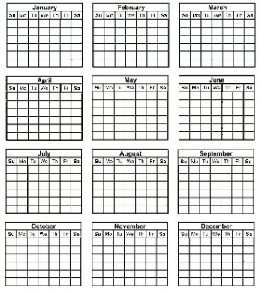

- less than 1 year. Like 6 months

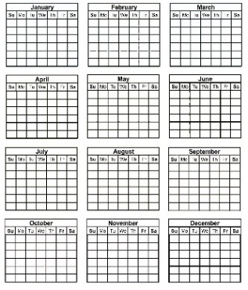
- 1 year
- 2 years

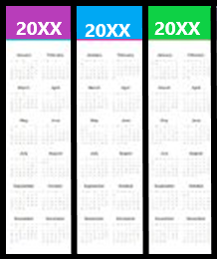
- 3 years
- 4 years
- 5 years

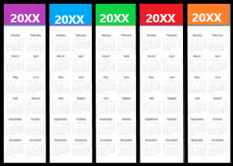
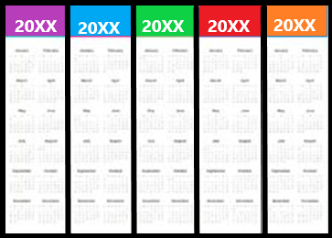

- more than 5 years. Like 10 years.

Or

Write how long you want to stay.

_______________________________________

Your needs may change. Like in 5 years.
You may need a different home.
Is this OK?



Yes. I can move to a new home.


No. I want to stay in the same home.

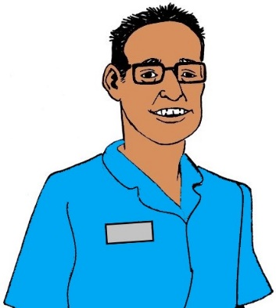
Will you need to change your help? You may need
- more help
- less help.

Yes
No.

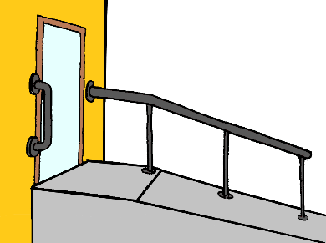
Will your home need some changes? Like
- a ramp
- wide doors.

Yes
No.

You may want to write more about
- the plan for your next home
- what may change. Like you need a wheel chair.

Write it here.

___________________________________________________________________________________________________________________________________________________________

What do you need to do next?
Like ask for help to make your plan.

Write it here.

____________________________________________________________________________________________________________________________________________________________

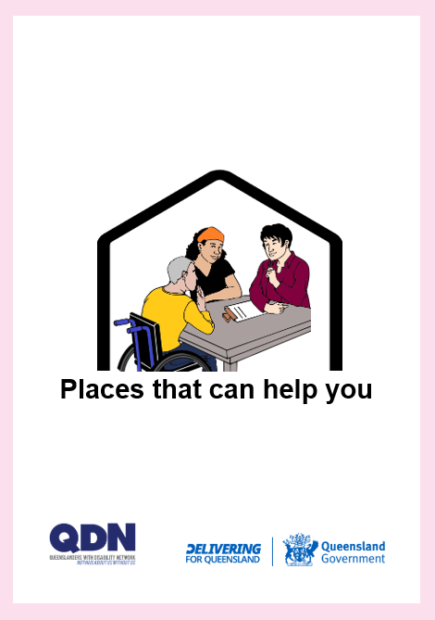
You need help to make your plan.
Read Places that can help you.

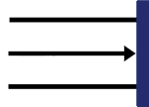
This is the end of this part.

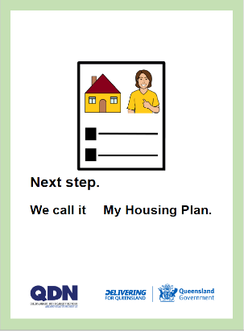
You can go to Next step.
We call it My Housing Plan.

