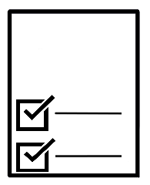
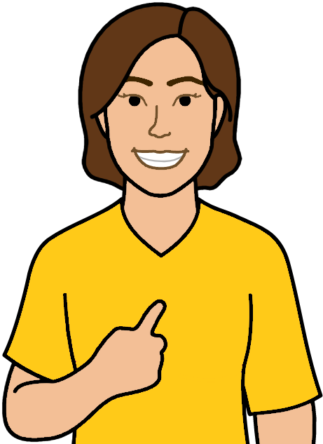
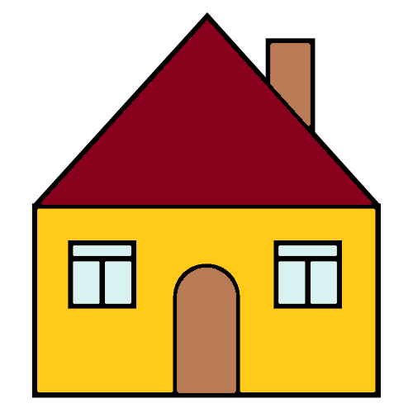


Next step.
We call it My Housing Plan.



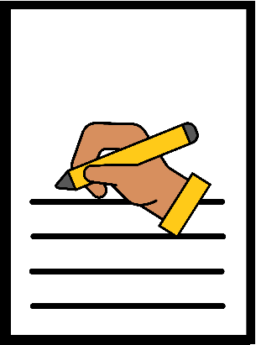
You have done all the work sheets.

Now

You need all your ideas in the 1 paper.
We call this My Housing Plan.

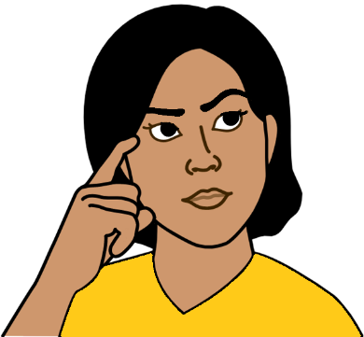
It will help you know
- what you need to do
- what to do now
- what to do next
- what help you may need to do your plan.

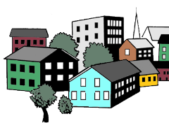
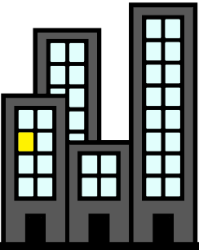
Things may change.
Like you change where you want to live.

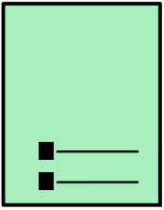
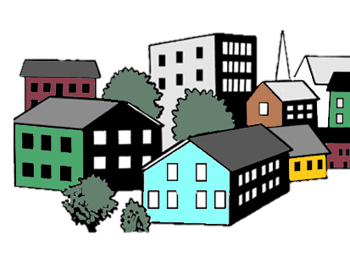
You put the change in your plan.
It will help you
- move to your home
- in the way you want.

Write your plan


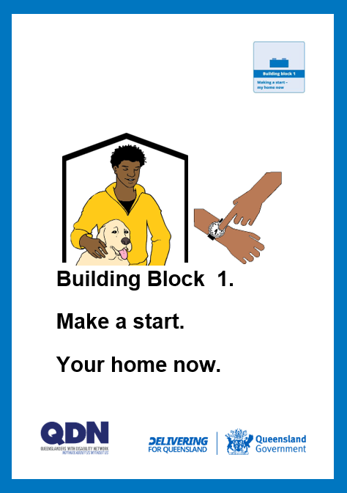
You wrote in
- Building Block 1. Make a start. Your home now.
- Building Block 2. Your home. What you want.
What help you need.
- Building Block 3. Money for your new home.
Plan for your next home.


You look at what you wrote.
You use it to write this plan.

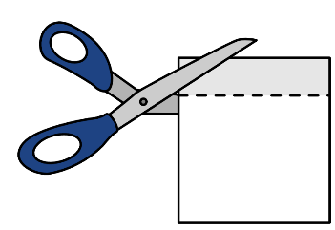

You can make your plan in different ways.
You may want to
- cut out what you wrote
- paste it in this plan.

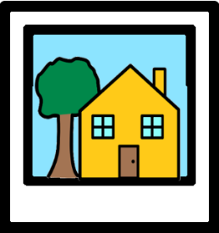

You may want to paste photos in your plan.

You may want to copy what you wrote here.

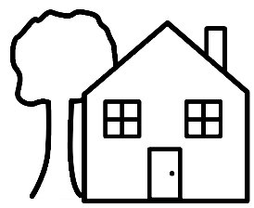
You may want to draw pictures.

My Housing Plan

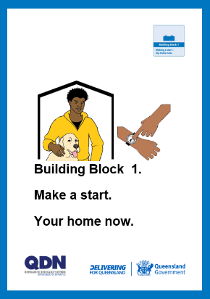
Look at your work sheet in Building Block 1.
Make a start. Your home now.

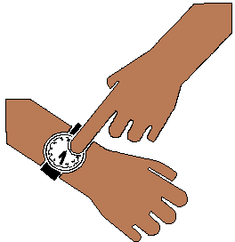

It is about your home now.


What home do you live in now? Like in a house.

_______________________________________

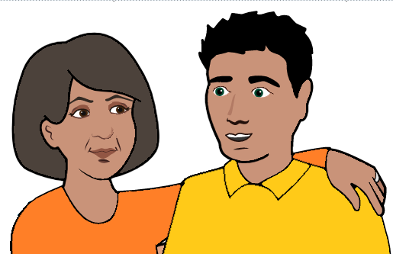
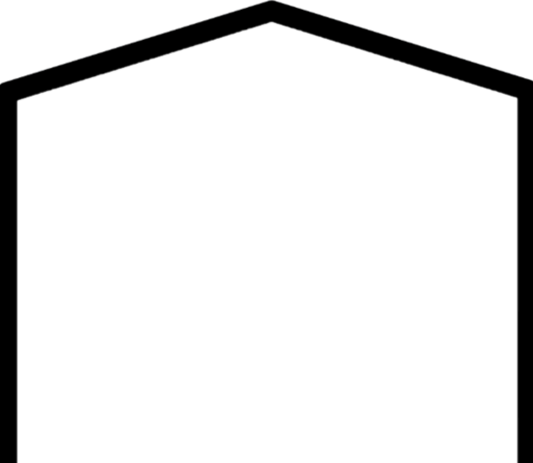

Who do you live with now? Like your mum.

_______________________________________
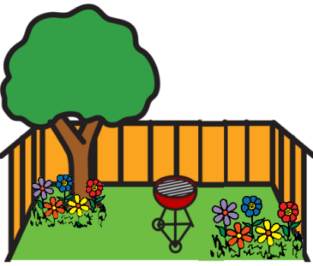
Think about how important some things are.
Like you want a big garden.
You find a house. It has the right size bed rooms.

But
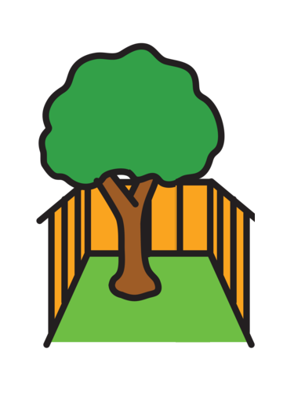

The garden is small.


You need to make a choice.
Like how important is a big garden to you?



Is it a thing you must have?

Or

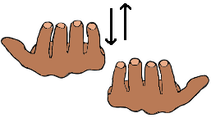
May be it will be OK.

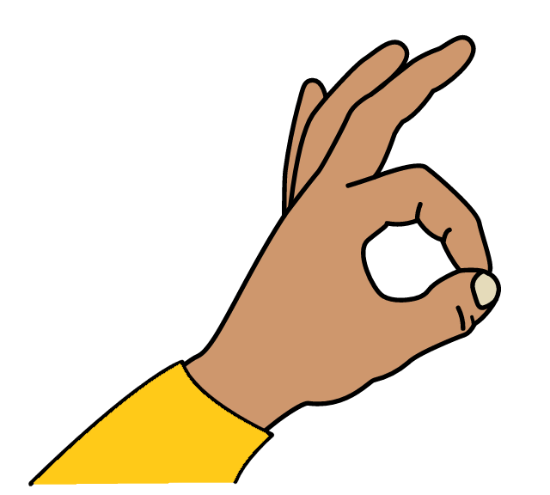
Like a small garden is OK.
You can go out side.

Or


You do not need it.
Like you do not need a garden.

Think about the home you live in now.
For each question.
Think about what you must have. You need it. We say it is important.

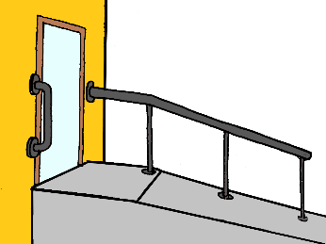

Things are easy to use.
Like there are ramps. There are hand rails.


Must have May be need Do not need

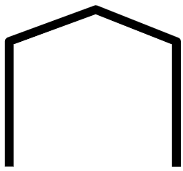

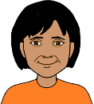
It is close to your family.
It is close to your friends.

Must have May be need Do not need


You have the money to live there.
It may be cheap to live there.
We say you can afford to live there.

Must have May be need Do not need



You feel safe in this home.

Must have May be need Do not need

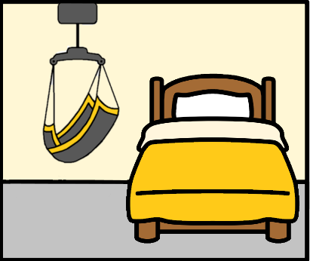
You have space for
- the things you need for your disability.
Like your hoist in your bed room
and
- other things you have. Like your big TV.

Must have May be need Do not need

There is a
- garden
- space out side.

Must have May be need Do not need

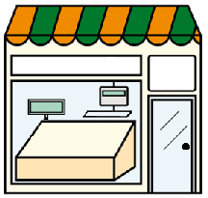
It is close to
- shops
- places you go.

Must have May be need Do not need


Now. You think about the same ideas.

But

It is for your new home.

For each question.
Is it a thing you must have? You need to have it. It is for your new home.
We say it is important to you.

Things will be easy to use.
Like there are ramps. There are hand rails.

Must have May be need Do not need

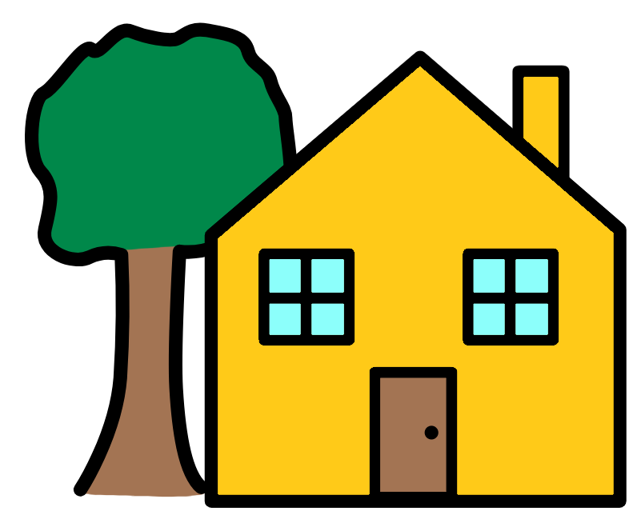
It will be close to your family.
It will be close to your friends.

Must have May be need Do not need

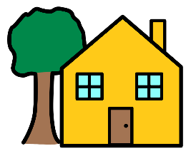
You will have the money to live there.
It may be cheap to live there.
We say you can afford to live there.

Must have May be need Do not need

You will feel safe. It is in your new home.

Must have May be need Do not need

You will have space for
        - the things you need for your disability.
Like your hoist in your bed room
and
        - other things you have. Like your TV.

Must have May be need Do not need

There will be a
        - garden
        - space out side.

Must have May be need Do not need

It will be close to
        - shops
        - places you go.

Must have May be need Do not need

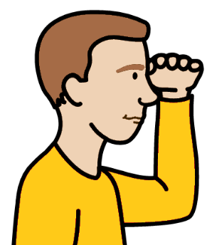
Look back to your work sheets.

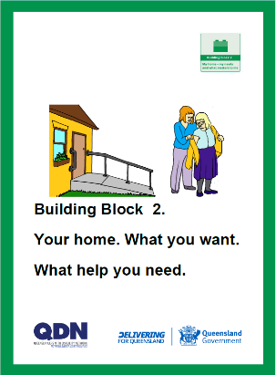
Read what you said in Building Block 2.
It was about
        - where you want to live
        - who you want to live with
        - what your home needs
        - what staff help you may need.

Find all the things that you must have.


Write them here.
You may want to paste what you said.
You may want to draw what you said.

______________________________________________________________________________
______________________________________________________________________________________________________________________________________________________________________________________________________________________________________________________________________________________________________________________________________________________________________________________________________
Find all the things you may need.

Write them here.
You may want to paste what you said.
You may want to draw what you said.

______________________________________________________________________________
___________________________________________________________________________________________________________________________________________________________________________________________________

Now


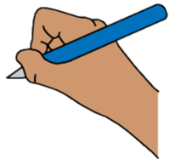
You write your plan.
You write the big things you want. Like
- you want to live in your own home
- you want to live near your family.
We call this your long term goal.

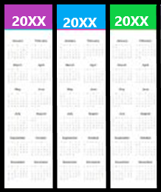

It may take some time. Like 3 years.

Write the big things you want.

___________________________________________________________________________________________________________________________________________________________________________________________________

You have small steps to get to your big step.
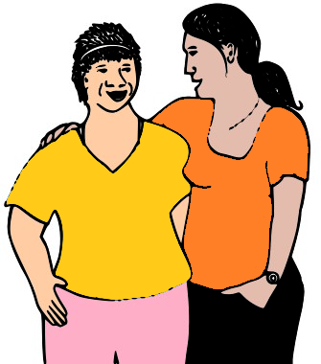
Like talk to
- your friends
- your family
- a group who knows about housing
- a group who knows about help you can get.
These steps are called short term goals.
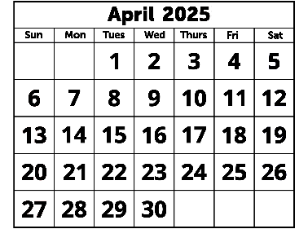
Each small step may take a short time.
Like each step may be
- 1 month

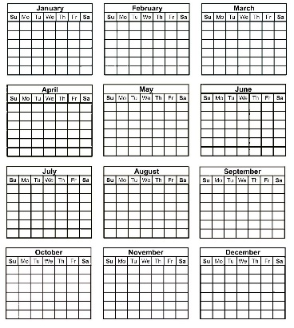
- 3 months.
It may take more time. That is OK.

Write your ideas for some small steps.

______________________________________________________________________________
______________________________________________________________________________You can write more small steps. _____________________________________________________________________________________________________________________
_____________________________________________________________________________________________________________________
_____________________________________________________________________________________________________________________
_____________________________________________________________________________________________________________________
______________________________________________________________________________
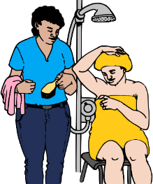
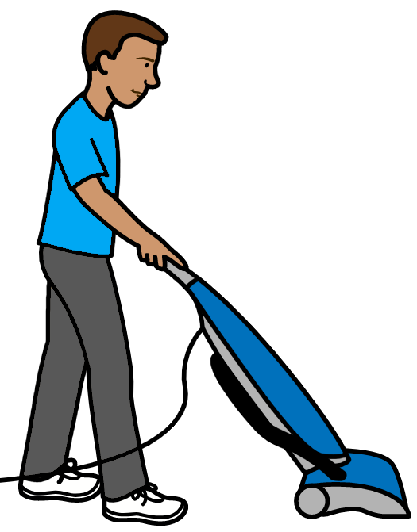
What help will you need?
You may need staff to help you do things.

Or
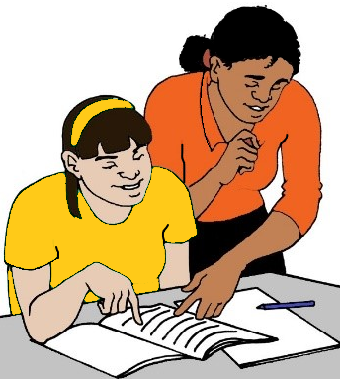

You may want to learn to do things.


Mark the boxes that are right for you.

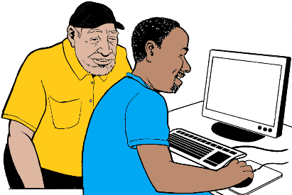

Will you need help to
- look for a home

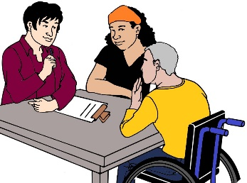
- ask for a home.
You may need help to apply

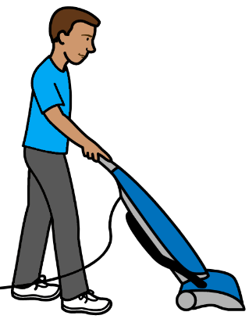

- clean your home


- do more jobs in your home?
Like the washing.

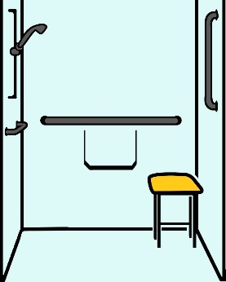

Will you need help to
- ask for changes in your home.
Like hand rails




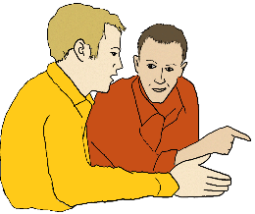
- work out what money you have
- plan what money you can spend

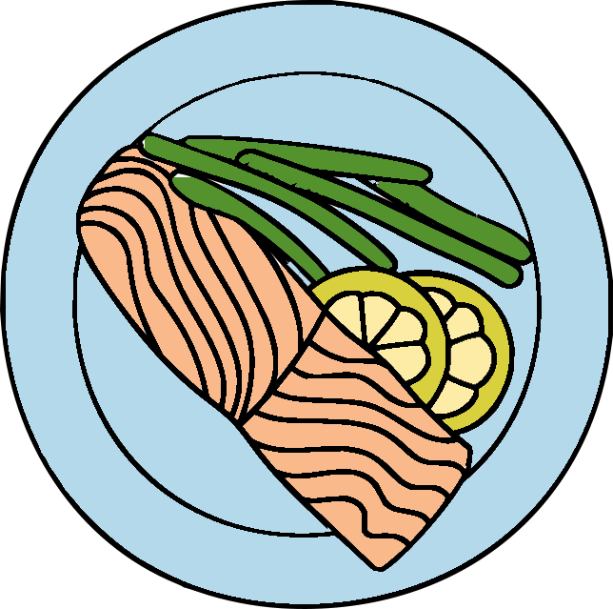
- plan your meals

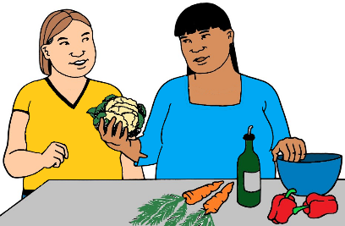
- cook meals

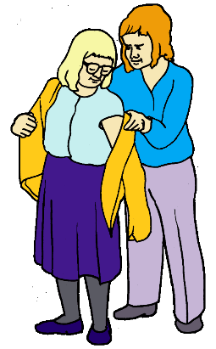
- get ready each day. Like get dressed
- have your shower


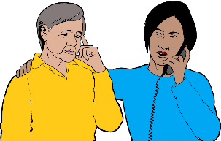
- find places you can go.
They will be close to your home.
Like the swimming pool

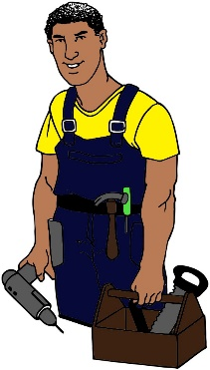
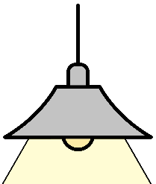
- fix things when they stop.
Like your light stops working

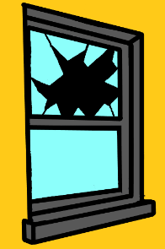
- fix things when they break?
Like a broken window.

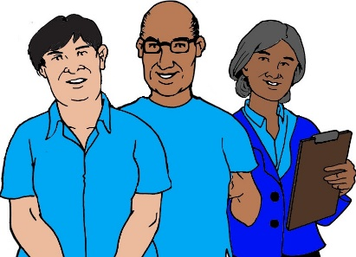
Will you need more staff help at home?

Write it here.

______________________________________________________________________________
___________________________________________________________________________________________________________________________________________________________________________________________________

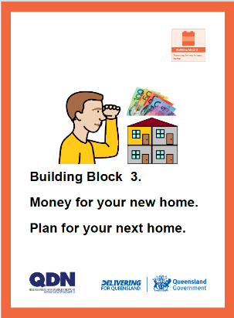
Look at your work sheets in Building Block 3.
They are
- Money for your new home.
- Plan for your next home.

Your plan helps you work out what to do next. Think about
- things you need to do
- help you may need.

Some things may take
- a long time. Like 6 months
- less time. Like you can do them today.
That is OK.

What can you do now? Like
- today
- this week.
It may be talk to different friends.

And


Who can help you?

Write it here.

______________________________________________________________________________
______________________________________________________________________________
Write more things you can do now. _____________________________________________________________________________________________________________________
_____________________________________________________________________________________________________________________
_____________________________________________________________________________________________________________________
_____________________________________________________________________________________________________________________
_______________________________
What can you do soon? Like in
- 1 month
- 3 months.

And

Who can help you?

Write it here.

______________________________________________________________________________
______________________________________________________________________________

Write more things you can do soon. _____________________________________________________________________________________________________________________
_____________________________________________________________________________________________________________________
_____________________________________________________________________________________________________________________
_____________________________________________________________________________________________________________________
_______________________________
What can you do later? Like after
- 3 months
- 6 months.
It may take more time. That is OK.

Who can help you?

Write it here.

______________________________________________________________________________
______________________________________________________________________________
Write more things you can do later. _____________________________________________________________________________________________________________________
_____________________________________________________________________________________________________________________
_____________________________________________________________________________________________________________________
_____________________________________________________________________________________________________________________
_______________________________
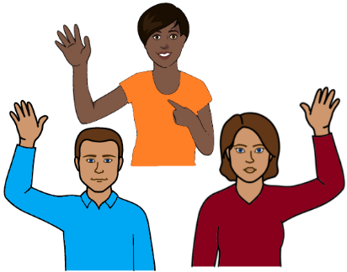
Who can help you?

Mark the boxes that are right for you.

- Mum. Dad. Your brother. Your aunt.

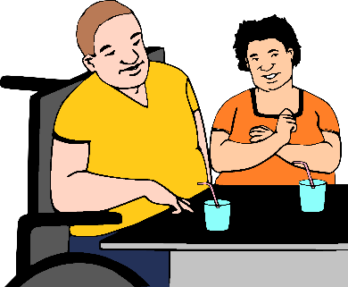

- friends

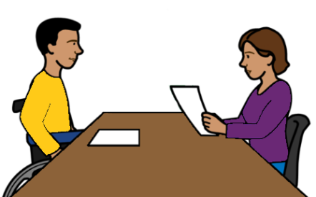
- support person for your NDIS plan

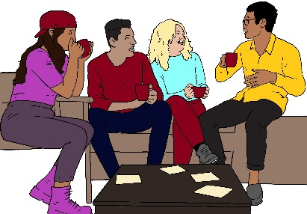
- people who help you speak up.
We call them advocacy groups



- a place that helps find a house

- a group that helps
people with disability. Like QDN.
There may be more people who help you.
Write it here.

______________________________________________________________________________
______________________________________________________________________________

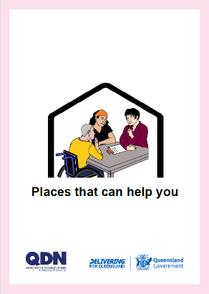
You want to find help.
Read Places that can help you.

You can write more notes here.

______________________________________________________________________________
___________________________________________________________________________________________________________________________________________________________________________________________________

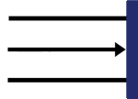
This is the end of My Housing Plan.

