
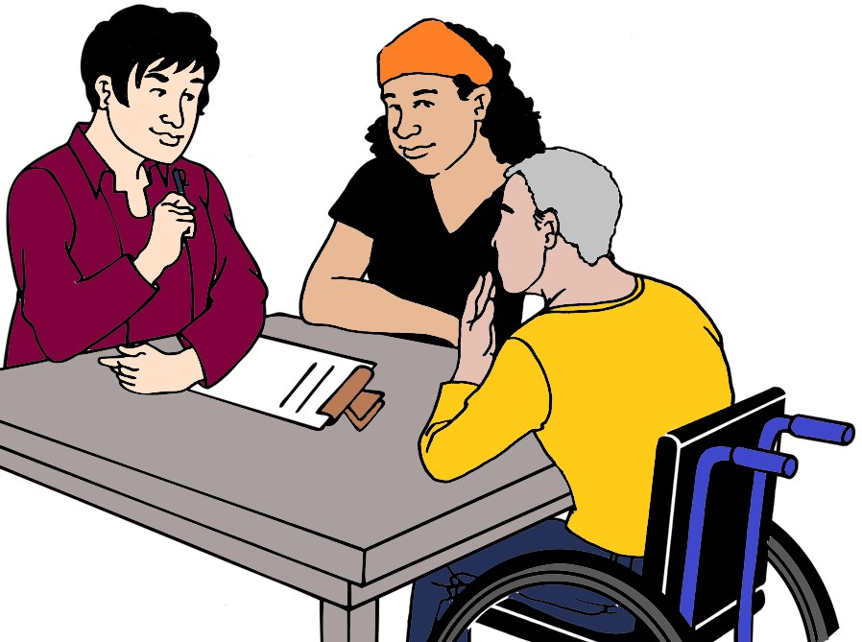

Places that can help you
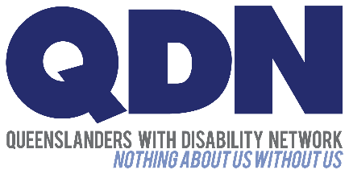
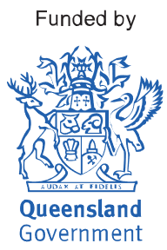
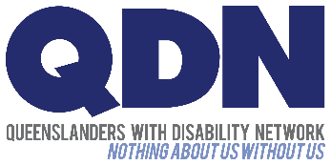
We are QDN. Our long name is
Queenslanders with Disability Network.

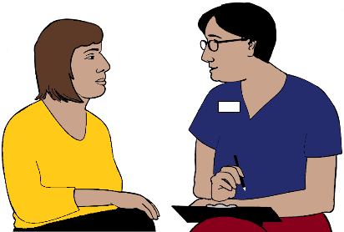
We help people with disabilities find
- more help
- groups you can join
- people to talk to. You can share your stories.



Call 1300 363 783.

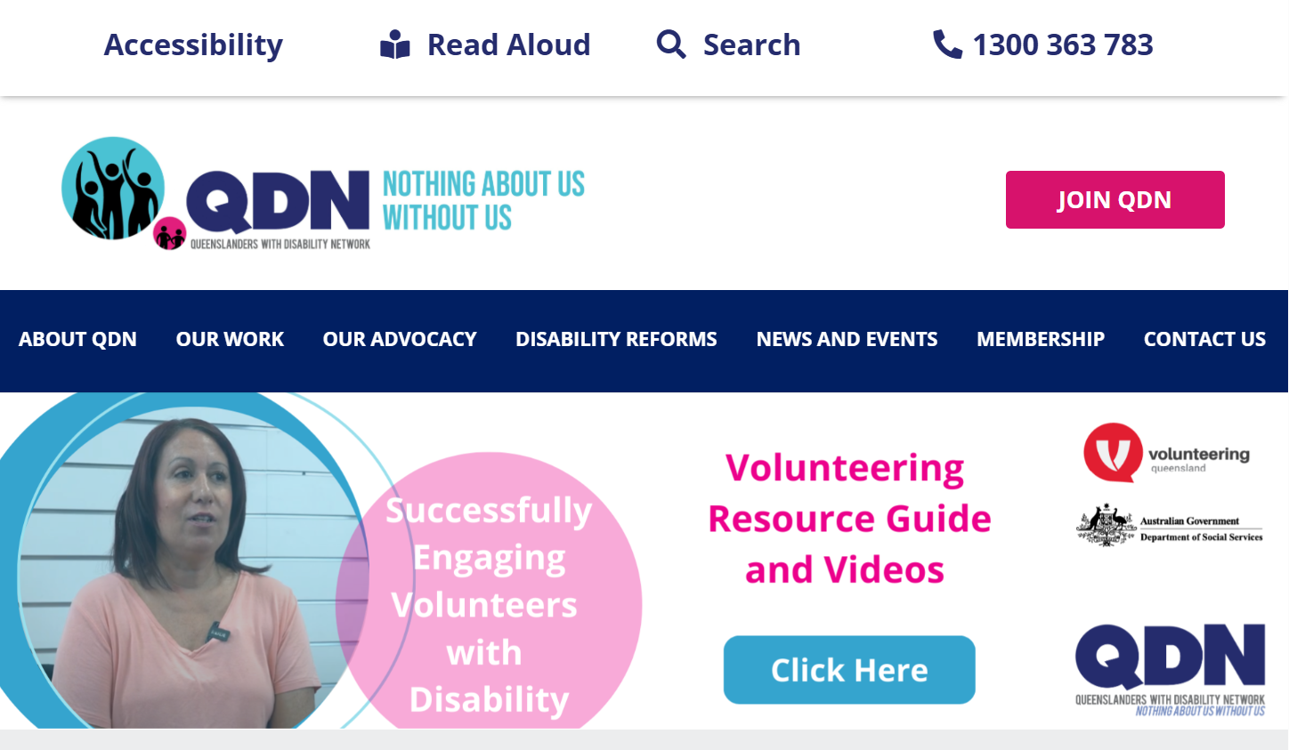


Go to www.qdn.org.au.

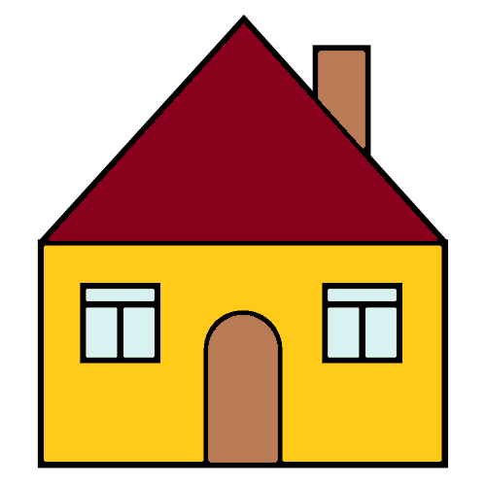

You need a place to live

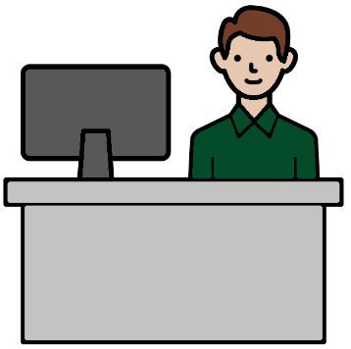
There are places to help you.
They are Housing Service Centres.
Staff are there to help you. They may help with
- your rent
- your bond.

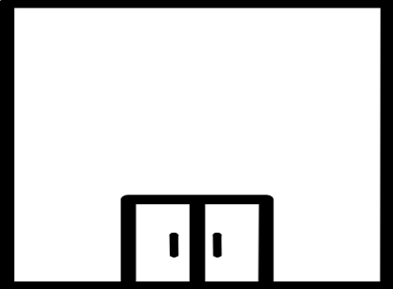
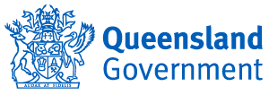
Call the Queensland Government. 13 74 68.
Ask
Where is a Housing Service Centre near me?



You rent your home

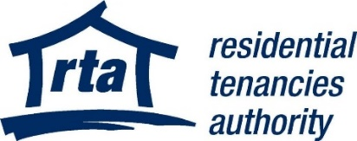
The RTA can help you
- know your rights
- know what to do. Like how to pay your bond.

Call 1300 366 311.


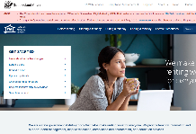

Go to www.rta.qld.gov.au.

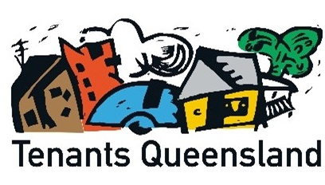
Tenants Queensland can help you
- know your rights
- know what to do. Like how to pay your bond.

Call 1300 744 263.

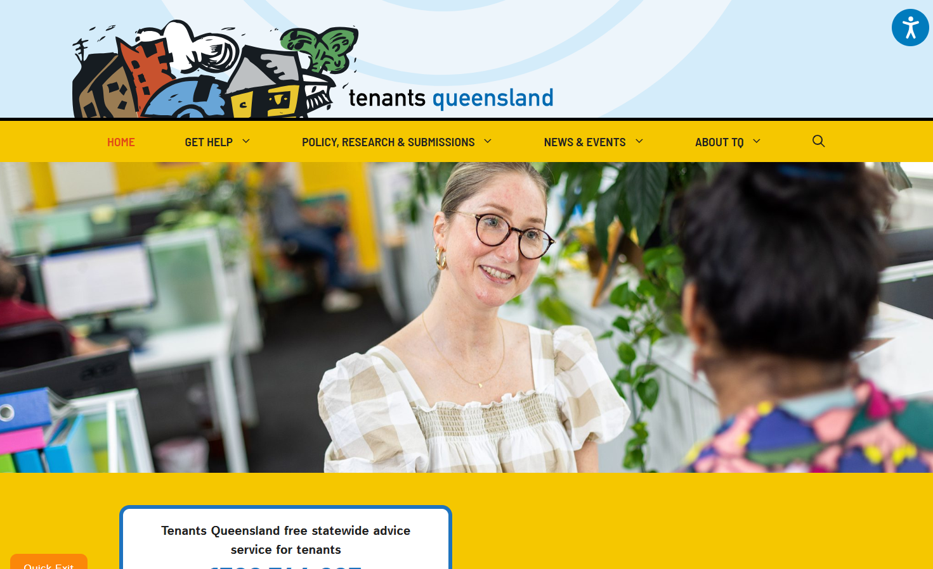

Go to www.TenantsQld.org.au

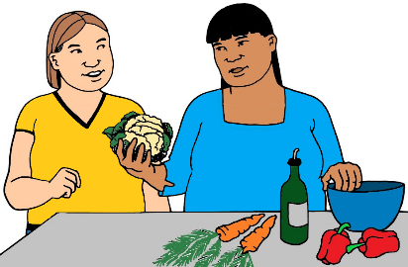

You need help at home

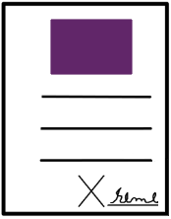

Your NDIS plan may help pay for
- staff to help you
- things to help you stay in your home
- a home with staff help. The NDIS call it SDA.
Only some people get SDA help.

Call 1800 800 110.

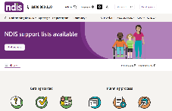

Go to www.ndis.gov.au.
You can not get an NDIS plan.
There may be different help you can get.
Like you get staff to help you. It is called QCSS.

Call QCSS. 1800 600 300.



You got hurt in a car crash

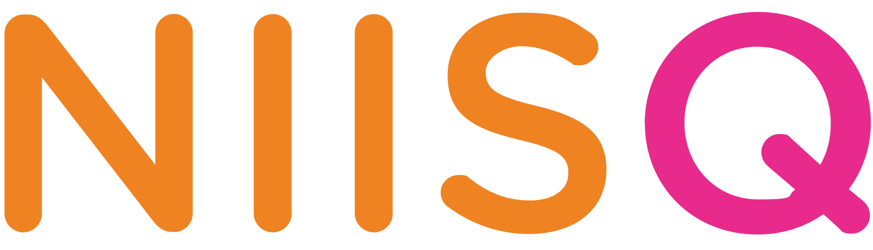
Talk to NIISQ. They may help you
- pay for changes to your home. Like a ramp
- find help you need. Like staff to help you.

Call 1300 607 566.

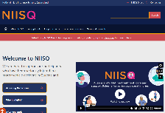

Go to www.niis.qld.gov.au.

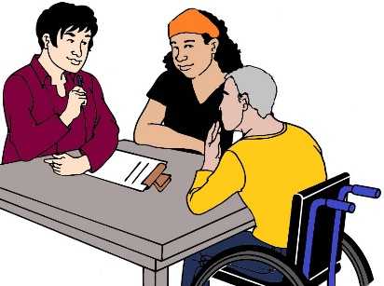
Help to

speak up for your rights

find out about more help

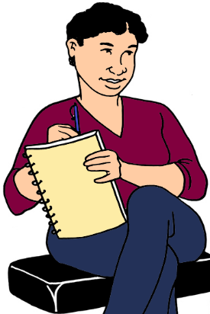
There are people to help you.
We call them advocates.
The Pathways Service can help you find one.

Call 1800 130 582.

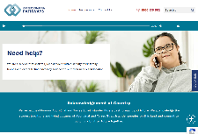

Go to www.DisabilityPathways.org.au.

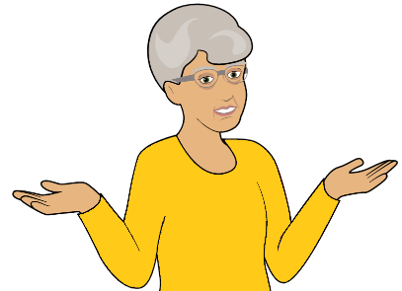

You do not know who to ask

Talk to QDN. We tell you who can help you.

Call 1300 363 783.

